CONTEMPORARY ISSUES AND CHALLENGES IN CYBER SECURITY
Memes, Confession Pages and Revenge Porn- The Novel forms of Cyberbullying
Hrishikesh Prakash Jaishwal
ABSTRACT
In today’s era, technology and the internet is influencing every aspect of our lives. From kids, to adults, to even elderly, we are exceedingly dependent on technology. Technology has its immense benefits, we can send messages from one part of the planet to the other with a click of a button. But with good, comes bad. With the emergence of social media, we have seen various transgressions, with Cyberbullying and online harassment being the prime examples of it. Cyberbullying means bullying an individual or a group using technology. The present article has four chapters to it. The former part of the first chapter aims to discuss the concept and modes of Cyberbullying, the latter part of it deals with the reasons and effects of Cyberbullying on the victims. The chapter also discusses the impact of COVID-19 pandemic on the Cyberbullying menace in India. The last chunk of the first chapter explains the legal aspects of Cyberbullying in India through legislations and case laws. The objective of the second chapter is to discuss the most recent forms of Cyberbullying, mainly memes, confession pages and revenge porn. These have been explained through real-life cases that have happened in premier educational institutions of India. The penultimate chapter of the article deliberates upon the problem of Cyberbullying through a survey which has been done with a sample size of 100 students from various parts of the country. Students from all fields of education, such as Law, Medical and Engineering have participated in the survey. The questions asked in the survey are revolving around the various aspects of Cyberbullying and revenge porn. The final leg of the article discusses the remedies and solutions to the problem of Cyberbullying and Cyber trolling.
Key Words: Cyberbullying, memes, trolling, revenge porn and COVID-19.

Contents
Chapter One- Cyberbullying In India 3
Introduction: 3
Concept of Cyberbullying: 3
Modes of Cyberbullying: 4
Reasons for Cyberbullying: 8
Gaming and Cyberbullying: 10
Cyberbullying in the times of Pandemic: 14
Cyberbullying Laws in India: 14
Important Case Laws: 18
Chapter Two- Live Examples 19
Memes: 19
Confession Pages: 24
Revenge Porn: 29
Chapter Three- Research Survey 34
Introduction about the study: 34
Objectives: 34
Hypothesis: 34
Research Questions (Questionnaire): 34
Sample for the study: 35
Research Tool: 39
Data collection: 39
Results and Analysis: 39
Chapter Four-Suggestions and Conclusions 47
Suggestions: 47
Conclusion: 49
Bibliography: 50

Chapter One- Cyberbullying In India

Introduction:
When we go by the definition, Cyberbullying happens “when one person or a group of people try to threaten, tease or embarrass someone else by using a mobile phone or the Internet.” In the twenty-first century, Cyberbullying is as harmful as bullying in the actual world. It has been noticed that the traits of preys of offline and online bullying are identical. With the expansion of social media, Cyberbullying can happen 24 hours a day, seven days a week and 365 days a year and even when the person is alone. Social media platforms such as Instagram, Facebook and YouTube give its users the ability to post photos, videos, documents and location etc., in-short anything under the sun. These may be of the account-holder or any other person. Cyberbullies use these features to humiliate and make fun of others. The most negative part of it is that almost all the subscribers of that social media platform get access to those messages or videos making it even worse for the person being attacked.
The main reason for Cyberbullying being so deleterious is that it gives the bullies the freedom to harm people at any hour during the day that to by using multiple platforms. There are hundreds of social media platforms these days that have uncontrolled and unmoderated content. The trolls and bullies can use any of them to target people. Cyberbullying can be done through mobile phones, mobile applications, laptops, tablets, I-pads, online games and even through electronic mails. In studies by Microsoft and McAfee, it was found that almost 50% of Indian youth at some point in life have faced Cyberbullying, also India was ranked 3rd in the countries with the highest bullying rates

Concept of Cyberbullying:
The term “Cyberbullying” was first used by Canadian educator Bill Belsey, creator of the Web site www.bullying.org. It is defined as, “using both information technology and communication technology beyond the limit in order to harm a person’s reputation, state of mind, or to humiliate a person. It is an act by which the person being bullied suffers an adverse effect.” Such acts of online harassment may be done by persons known or unknown to each other. The main aim of a cyberbully is to injure and distress the person who is generally physically or emotionally weaker than them. Cyberbullying can take various forms such as false rumors, morphed pictures, altered videos, fake news and sexual remarks etc.

Modes of Cyberbullying:
The types of Cyberbullying can be majorly divided into 2 parts i.e. Cyberstalking and Online trolling.
Figure 1: Types of Cyberbullying
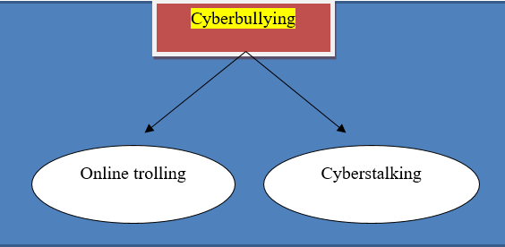
Online trolling: In world wide web, a troll is a person who publishes and posts defamatory, abusive, sexual and off topic content over the internet. The biggest advantage for trolls is that their identity is anonymous. Trolling is different from cyberstalking in the regard that both the parties involved are generally unknown to each other and is done generally out of amusement and fun. A study done in the University of Manitoba, in Canada, found that trolls exhibit the personality traits of “narcissists, psychopaths and sadists –taking pleasure in the suﬀering of others and lacking remorse or empathy for their victims.” It is noticed that people turn into trolls due to mental problems, sexual problems, ill childhood and ignorance etc. In the times of pandemic, when most of us are staying at home or working from home, we have seen a lot of examples of online trolling, for example- the violence and rape threats being given to Ziva Mahendra Singh Dhoni on her Instagram posts to insulting and offensive comments on movie trailers and songs of a certain section of Bollywood celebrities.
Cyberstalking: it is another form of online bullying in which the offender threatens or troubles the victim using electronic communication. The National Commission for Women (“NCW”) in its legal module on ‘Gender Sensitization and Legal Awareness Programme' defines cyberstalking as following “Stalkers are strengthened by the anonymity the internet offers. He may be on the other side of the earth, or a next-door neighbor or a near relative!' It involves following a person's movements across the Internet by posting messages (sometimes threatening) on the bulletin boards frequented by the victim, entering the chatrooms frequented by the victim, constantly bombarding the victim with emails, etc. In general, the stalker intends to cause emotional distress and has no legitimate purpose to his communications.” This form of harassment is much worse due to its personalized nature. The offender and the victims have a direct connection and contact thus doing more damage. Cyberstalking is the most harmful form of Cyberbullying as here the safety of the person affected is at risk. Normally, Cyberstalking is done by sending recurrent messages and photos to the person. In some cases the stalker even asks others to do the same, thus harassing the person mentally and psychologically.
Methods of Cyberbullying: Cyber harassment can take various forms and ways, here is a list of ways in which Cyberbullying starts-
- Posting wrong statements- It has been observed that cyberbullies post false things about the victim on social media platforms. The false statements are aimed to defame and humiliate the person in front of millions of people over the internet. This practice is happening a lot on platforms such a WhatsApp and Facebook, where a lot of fake forwards are done. Recent incidents of violence and mob lynching are credited to such WhatsApp forwards. A lot of women are slut and witch-shamed through WhatsApp forwards which tends to destroy their lives. The recent case of Bollywood actor Rhea Chakraborty is the perfect example of this kind.
- Rumors and Fake news- This is a recent phenomenon, here the victim is targeted by people known to them by sharing false news. This is done with the motive to created hatred and dislike in the minds of others. This type of Cyberbullying is mainly related to the love and sexuality part of the victims. Rumors of love affairs and cheating are generally fake and are done with an aim to defame the person. This practice is seen a lot in teens and college-going students.
- Repeat messages- This is one of the most used tools for cyber harassment. In this, the perpetrator uses social media applications such as WhatsApp, E-mails, Instagram DM’s and Facebook messages to continuously message and contact the victim. This is done mainly to create fear in the minds of the victims. Nowadays software such as SMS bombers and Call bombers have made the jobs for the stalkers easier. These apps provide a mechanism through which on a click the victim would receive innumerable One Time Passwords and messages. Social media platforms such as Twitter and Instagram provide all their users a feature to directly message any person they want, leading to a lot of unwanted messages. Females are generally a target of such forms of Cyberbullying.
- Threats and violence- Social media of today is filled with a lot of anger and hatred. Rape and assault threats have become increasingly common. Out of 100 comments on a YouTube video, at least 10 of them are of a violent and extreme nature. This type of Cyberbullying is mainly prevalent in areas of politics and public life. Politicians and celebrities are a target of such activities. The online age has become so aggressive that people go to the extent of giving rape threats to even senior citizens and children. Most of the females on social media who tend to speak up against someone or something are prone to such abuses. Recently, Agrima Joshua, a standup comic by profession was a victim of online abuses and rape threats because of her jokes on the Maharashtra government. Such acts are becoming frequent because a lot of uneducated mass in India is being exposed to the internet.
- Impersonation- This is done by creating fake profiles of the victim and then posting and commenting stuff that is likely to get discredit and ridicule to the victim. Creating a social media profile is child’s play, most of the websites ask only for email IDs to open new accounts and creating them is even simpler. At one click, ID with any name is made. By now every person might be having a profile named Angel Priya in their Facebook friend list.
With the Reliance-Jio internet revolution, more and more people are being made known to the world of internet and social media. Telecom giants such as Reliance Jio and Bharti Airtel are adding millions of subscribers daily. With smartphone prices sinking, even the people from the remotest parts are being able to easily access the internet, which in turn, is leading to increased Cyberbullying. There is a sense of digital illiteracy in India and most of the users are of the opinion that their acts cannot be detected or controlled.

Reasons for Cyberbullying:
It is to be found that cyberbullies are mainly within the age bracket of 14-25, thus they have a deficiency of understanding and knowledge of their actions. They are usually unaware of the consequences of what they do. One of the primary reasons for such behavior is their tender age and lack of maturity. For adults and college goers, the main reasons for bullying are lack of work, irritation, frustration and need for fun. The people who involve in Cyberbullying are the same ones who might bully people in real life. Bullies are generally ignorant of the fact that their behavior and actions might seriously affect the person being bullied. Nowadays, the internet is seen as a tool to showcase one's power and nemesis. The thirst for power and fame leads people into harassment and online bullying. The art of trolling a person is seen as a status symbol and people tend to cross limits for becoming popular. The best examples of this are You tubers such as Carryminati and The Rawknee Show. In the current time, college and school students have titles for students such as “Best Memer” and “Best Roaster” etc. The youth thinks that roasting and insulting a person will make them look cool among their peers. Jealousy is one of the most significant reasons for Cyberbullying. In today’s age, colleges are not less than a war front, students tend to compete a lot and in the rage of it, cross all the limits. Achievements for one is a source of jealousy for others. Rejections and heartbreaks are also a source of Cyberbullying, the people facing rejections are not able to accept that fact, and thus indulge in Cyberbullying for revenge. Some examples of this are creating a fake profile; spreading false rumors; and slut-shaming.
Effects of technology and social media:
Undoubtedly, the internet is the biggest gift to humanity. We are a digitally dependent world. Internet and technology can solve all our problems. Be it learning, playing or working, we are dependent on computers and the internet. But, technology has its own positives and negatives and when the latter starts to overtake the former, we need a mechanism to stop it. With evolving time, we are witnessing various ways in which technology is turning into a monster. The most serious effect of technology is the way in which it is affecting our mental health and peace. Social media has tons of benefits but not every person is capable of using it positively. While looking at the positive side, which we all are enjoying, the negative effects at times go unnoticed. They are listed down:
- Lack of soft skills- The youth of today is seen spending a lot of their time on mobiles and laptops. They may be experts in chatting and typing, but when it comes to social and communication skills, they are a big flop. With the global epidemic of Corona, schools and colleges throughout the country are shut, thus the students are not able to physically interact with their friends etc. which is harming their social growth.
- Anxiety and depression- Mental disorders are on an ever-increasing rise. According to a study, 43% of Indians are suffering from some form of depression. In youth, performance pressure is one of the primary reasons for depression.
- Comparison- Internet gives easy access to the social media profiles of others. People update their achievements and other good memories on social media which is seen by others. This exposure to other’s lives creates a sense of jealousy. People tend to compare their lives with others which leads to gloominess.
- Loss of productivity- Today’s young generation spends a lot of time on social media. Online games such as PUBG and online poker are a full waste of time and productivity. Indian parents are a bit unaware about mobile phones and gaming, and thus they are easily fooled by their wards. Dating apps such as Tinder and Omegle provides children with unrestricted access to content which is not for their age.
Negative effects of Cyberbullying:
There are far-reaching repercussions of Cyberbullying, some of them are:
- Frustration- Forms of Cyberbullying such as repeat messages and impersonation leads to frustration among the victim.
- Scared- Victims of Cyberbullying are scared to socialize. They tend to become quiet and lonely and avoid friends and family.
- Become suicidal- It has been studied that in most of the cases of suicide, the victim in one or the other way was subjected to bullying and harassment. In many cases, such facts do not come out due to difficulty in finding the nexus between bullying and suicide.
- Anger- The victims of online trolling get used to being angry, even at small and indifferent instances they lose their patience and temper.
- Low morale- The person being bullied generally suffer from low self-esteem and confidence. They tend to keep everything to themselves. Teen victims do not consult their parents regarding such happenings because most of the time the topic of discussion is such that they are not comfortable in discussing it with them.

Gaming and Cyberbullying:
According to Statista.com, India has approximately 700 million internet users as of 2020 (Figure 2.0), with almost 53% of them falling within the age gap of 16-29 (Figure 3.0). It is also found that an average Indian adult spends 1 hour, 12 minutes in a day online and the majority of that time (76.5%) it is through mobile devices. 41% of users agree that they are addicted to their phone. There is a rapid increase in Cyberbullying through social media networks such as Facebook and Twitter but Cyberbullying is not contained to social media itself, there is a rampant increase in Cyberbullying through E-mails, SMS and online gaming. According to a study by Child Rights and You(CRY), 1/4th of the internet users from the age of (13-18) have experienced Cyberbullying and trolling, and this statistic is in direct correlation with the amount of time spent on the internet. According to the National Crime Records Bureau, Cases of cyberstalking or bullying of women or children increased by 36% from 542 in 2017 to 739 in 2018, also 223 cases of threatening/blackmail were registered. In all, there has been a 25% increase in the number of cybercrime cases from 2017 to 2018 (Figure 4.0). In 2020, Facebook was the most popular social media platform with 75% of the market share, which was followed by YouTube at 11% (Figure 5.0). The episode of (Bois Locker room) is sufficient for us to understand the level of toxicity and negativity present on the internet.
21st Century saw a lot of development in terms of technology and electronics. Gone the days when children used to play in parks and grounds. Cricket is still the first choice of any average Indian child but now they prefer to play ‘street cricket’ on mobile and Play Station rather than on actual streets. During this decade, we saw a lot of new E-games coming up. India’s video-gaming industry is valued at INR 90 billion in FY 2020.
According to various studies, it was found that children who play violent games tend to become cyberbullies in future. Alcohol consumption; time spent on screens; and the negative and ignorant attitude of parents are the key contributors to cyberbullying. Most of the online games provide a feature of chatting and commenting. This becomes a breeding ground for stalkers and trolls. According to the 2020 Indian Express survey, About 76% of respondents feel that addiction to action games lead to changed behavior and can increase depression and anxiety levels. Nearly 70 % of respondents feel that children connecting with strangers while playing games online can lead to cyberbullying, harassment, and violence. Though it may be prejudiced that online gaming is much of a fun for males, but it also attracts a lot of females. According to the same study, About 88% of females find online games to be the best pastime as compared to 86% of their male counterparts. But, it is also to be mentioned that women experience more harassment and bullying on these online video games. This can be noticed on the online videos of female live streamers. Hence online gaming does influence cyberbullying.
Figure 2: Number of internet users in India from 2015-2020
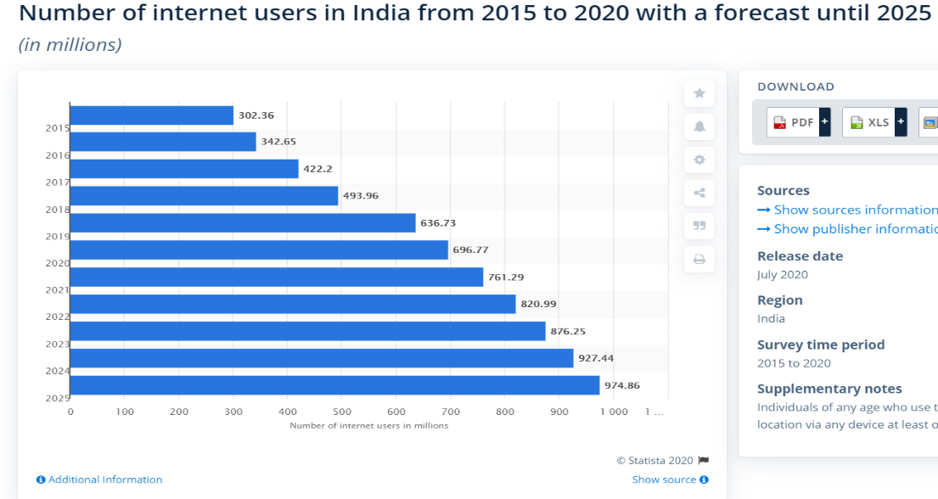
Figure 3: Distribution of internet users in India in 2019
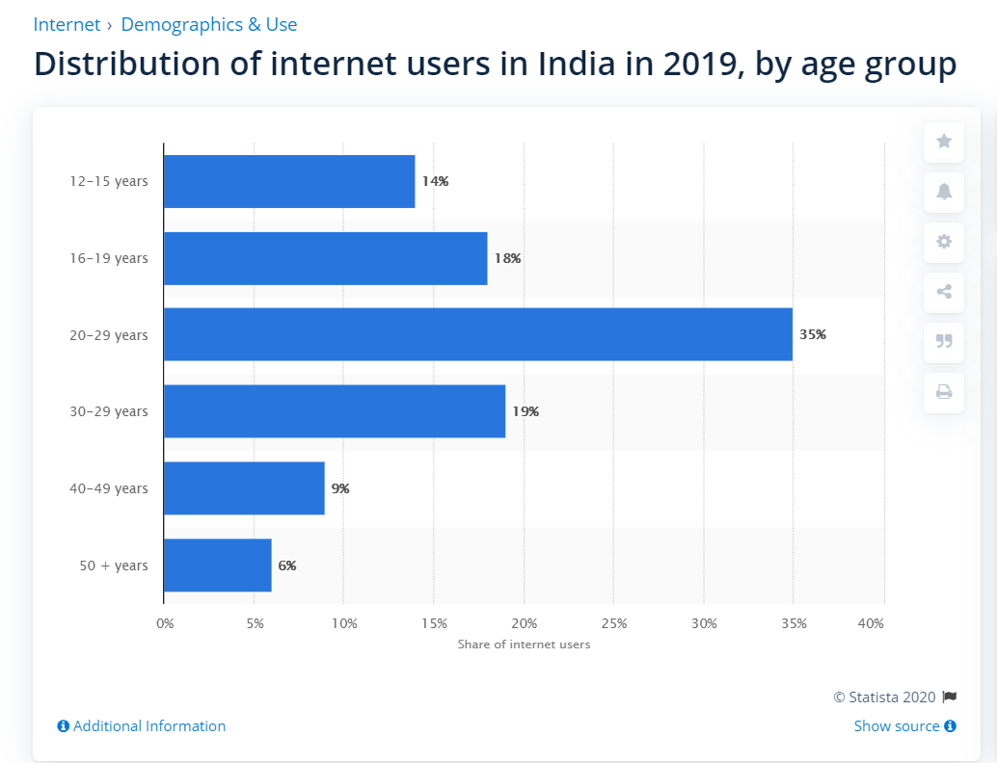

Figure 4: Cyber Crime cases in India in 2017-18
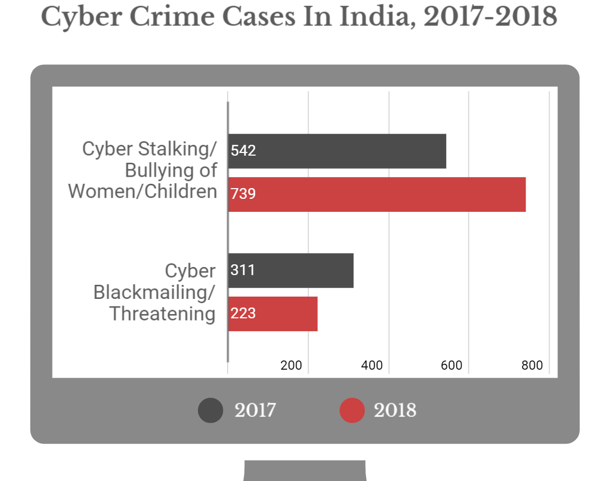

Figure 5: Social Media statistics in India
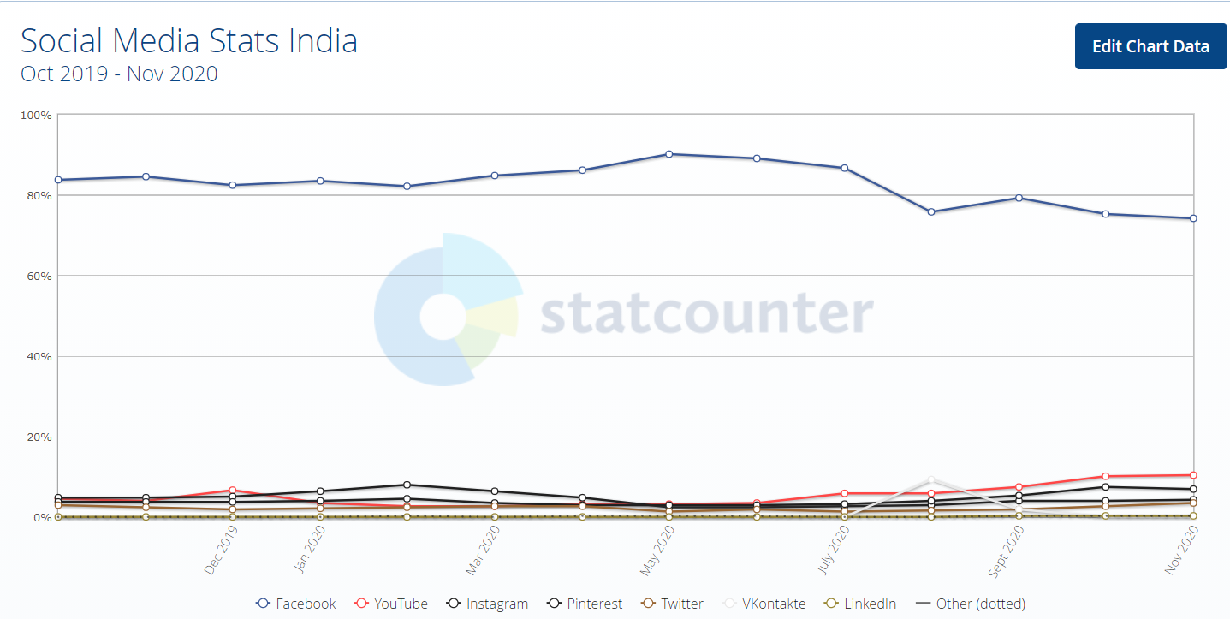

Cyberbullying in the times of Pandemic:
The novel Coronavirus pandemic has led to a rise in students using technology for all types of uses. Since March 2020, all the schools, colleges and educational institutions in India are shut down. There has been a sudden shift from offline campus education to online digital education. Students throughout the country are using software such as Zoom Meeting and Google Meet to attend online lectures. As most of us are not able to leave our places due to the risk of virus transmission, the average on-screen time of all the students has increased. There is a humongous surge in data consumption by everyone. This is a blessing in disguise for trolls and bullies as they are getting frequent targets to quench their thirst for harassment. Apps such as ‘Rummy Circle’ and ‘Teen Patti’ have become hubs of cyber frauds and online bullying.
Everyone is aware of the “dislike army of YouTube”, they are a group of likeminded people, who out of anger and fun start to dislike-crashing videos of celebrities and politicians. Since September 2020, all the videos uploaded on the YouTube channel of the Hon’ble PM Modi have more dislikes than likes, and the credit goes to the ban of online game PUBG to which a large chunk of Indians are addicted. Due to lockdowns and travel restrictions, partners are not able to physically meet, which is leading to the exchange of sexualized images and videos with each other, being unaware that such media can be stolen and misused. One of the most controversial apps of today’s time, ‘TikTok’ also had to face backlash from the Indian audience due to the misogynistic and harassing content made by certain creators. To conclude, it can be rightly said that as schoolwork has moved home, so has bullying and harassment.

Cyberbullying Laws in India:
It would be wrong to say that India has no legal regime which covers Cybercrimes such as Cyberbullying and stalking. Cyberbullying laws in India are general in nature i.e. not catering to a specific age group or sex. India has no dedicated legislation making Cyberbullying an offence, but certain provisions of Indian Penal Code, 1860(“IPC”); Code of Criminal Procedure, 1973(“CrPC”); Information and Technology Act, 2000(“IT Act”); Protection of Children from Sexual Offences Act, 2012 (“POCSO Act”), Sexual Harassment of Women at Workplace (Prevention, Prohibition and Redressal) Act 2013 ("POSH Act") do cover various aspects of Cyberbullying.
- Indian Penal Code, 1860-
- Section 292 A IPC- This provision states that if a person uses any picture or video which may be grossly indecent to blackmail the other person of publishing or publicly exhibiting it, shall be punished with imprisonment of either description for a term which may extend to two years, or fine, or both. This is a gender-neutral offence as the word “whoever” is used.
Example- If a person has a sexual photo/video of any other person, and he/she blackmails the person to upload it on Facebook, is liable to be booked under this section.

- Sec 354 A IPC- These sections were added to the IPC after the 2013 Amendment, it states that if a man request for sexual favors; or shows pornography against the will of a woman; or makes sexually coloured remarks, shall be guilty of the offence of sexual harassment. It is a gender-specific offence i.e. only men can be booked for these offences. The maximum punishment for such offences is 3 years, or fine, or both. Also, there is no mention in the provision that there has to be a physical presence of the offender for the offence to be committed.
Example-
- A man sending pictures of his private parts to women without their consent.
- A man commenting about a women’s character on her social media profile.

- Sec 354 C IPC- A man will be booked under this section if he watches, or captures, or disseminates the image of a woman engaging in a private act in circumstances where she would usually have the expectation of not being observed, shall be punished with imprisonment of either description for a term which shall not be less than one year, but which may extend to three years, and shall also be liable to fine. Where the victim consents to the capture of the images or any act, but not to their dissemination to third persons and where such image or act is disseminated, such dissemination shall be considered an offence under this section.
Example- If a woman send her private pictures to a man and he shares it with his friends, then he is liable to be booked under this section.
- Sec 354 D IPC- If a man follows, or contacts, or attempts to contact a woman virtually over the internet or through electronic communication repeatedly despite a clear indication of disinterest by such woman, commits the offence of Stalking. The prescribed punishment under the code is a maximum of 3 years, or fine, or both.
Example- If a man is sending regular messages to a woman despite her clear resistance, he is liable under section 354 D.
- Sec 503 IPC- This section punishes a person who sends threatening messages to another person with the intent to cause alarm to that person or to cause that person to do any act which he is not legally bound to do or to omit to do any act which that person is legally entitled to do, as the means of avoiding the execution of such threat. This is a gender-neutral provision and the offender gets a maximum punishment of 2 years, or fine, or both.
Example- If a woman send a mail to a person stating that if he does not transfer rupees 10000 to her account, she will harm his son
- Sec 507 IPC- This is similar to the offence stated under Section 503, but the only difference is that here the identity of the perpetrator is anonymous or fake.
Example- If a man uses a fake Instagram account to send messages threatening a minister to leak his intimate videos if he does not sanction certain documents, is liable for this offence.
- Sec 499 IPC- If a person defames another person over the internet is liable under this section. The main ingredient here is that the publication should be to someone else apart from the victim. Whoever defames another shall be punished with simple imprisonment for a term which may extend to two years, or with fine, or with both.
Example-
- If a person tweets on Twitter stating that the other person is corrupt and has taken a bribe of 1 lac rupees to pass tender and this information reaches to the mass at large, then the person is liable for defamation.
- If a person comments on a celebrity’s Tik-Tok video that she is transgender, while in reality, she is not, then the person has committed an offence under Section 499 of IPC.

- Information and Technology Act, 2000
- Sec 66 C- If any person fraudulently or dishonestly uses the other person’s password, signature or OTP is liable with simple imprisonment for a maximum term of 3 years.
Example- If a person unlocks another person’s phone using his passcode without his permission and sends defamatory message to his friend, then he is liable under this provision.
- Sec 66 D- If a person cheats and the other person by impersonation, he/she is liable for maximum punishment for 3 years. All the phishing offences come under this section
Example- If a person impersonates himself into being a bank employee and ask the other person for his bank OTP is liable under this section.
- Sec 66 E- If any man or woman knowingly violates the privacy of a person by capturing, publishing or transmitting the image of a private area of any person without his or her consent, is liable for an imprisonment of maximum of 3 years, or fine, or both. It is a gender-neutral provision, unlike Section 354 C of IPC.
Example- If a woman posts a naked picture of a man over his Pinterest timeline then she is liable under this provision.
- Sec 67 B- If a person transmits, browses, publishes or facilitates child intimacy and pornography, he/she is liable to be punished with imprisonment of either description for a term which may extend to five years and with fine which may extend to ten lakh rupees.
Example- If a man by getting into a relationship with a minor girl gets access to her obscene pictures and uploads it on an adult site, he is liable for child pornography under this code.

Important Case Laws:
Sharat Babu Digumarti v. Government of NCT of Delhi
Facts- In this case, a vulgar video was being sold in the form of E-book on a website, thus the question arose before the Court, whether the offender is tried under the IPC or the IT act.
Held- In this landmark Apex Court judgement it was laid that as the video was in electronic form hence IT Act should be applied. And, IT act which is a special law will prevail over IPC which is a general law.
State of West Bengal v. Animesh Boxi
Facts- Here, the accused hacked the victim's phone and stole her naked photos and later uploaded them on adult websites.
Held- The Court held that the accused is liable to be punished under sections 354A, 354C, 354D, 509 of IPC and sections 66C and 66E of the IT Act. The Court was of the view that such harsh punishment will act as a deterrence and will make people sensitive about this issue.
Prakhar Sharma v. The State of Madhya Pradesh
Facts- In this case, the accused created a fake social media account of the victim and uploaded her indecent photos on it.
Held- The Court charged the accused of Sections 354A, 354D, 500, 509, 507 of IPC and Section 67A of the IT Act and his bail applications were rejected.

Chapter Two- Live Examples

Memes:
A Meme is an image or visual representation of a funny thought or idea. The word was first used by Mr Dawkins, who considered it to be a social phenomenon of spreading of cultural ideas from person to person. The word ‘trend’ is similar to meme. There is no fixed mode of representation per se, but generally, memes are in the form of a photo or video. Memes are making people’s lives easier as one does not need to take the effort to read a foot long paragraph to get laughter. Memes can spread through any medium such as Facebook, WhatsApp and Twitter etc., but nowadays there are special meme-only apps such as Reddit and Meme Chat.
Memes as a form of Cyberbullying: The idea behind memes was to elicit humor but unfortunately, it has become a tool used for targeting and harassing people. Due to lack of sensitization and unawareness of the consequences among the ‘memers’, as one may like to call them, memes have become one of the most serious forms of internet trolling. Within seconds of the happening of an event, the internet is full of trolls and memes on that event. Memes are to be found on almost all social media platforms. Memes are used not only to target individuals but a class as a whole. There are Facebook and Instagram pages targeting a specific caste, sexual orientation, religion and races. Schools and colleges have also been engulfed by the meme culture. There are specific titles such as ‘Memelords’ and ‘Memegods’ given to students. It has been observed that most of the time these memes are targeting a particular student or a teacher and their creation is having a sexist and vulgar tone. Most of the times the makers are unknown or they use a different credit name, thus keeping their identity safe. Though memes give us a happy cheer, it may have a dreadful effect on the person who has been targeted by them. We have seen examples of celebrities such as Sonakshi Sinha and Sonam Kapoor who have taken a break from social media due to the massive amount of memes and trolling going on over them. The same is the case with the youth, a lot of them have to face humiliation and embarrassment due to online trolling. All these scenarios have been explained below using examples:
- The Humans of Patriarchy controversy
In April 2020, a meme page from one of the premier colleges of India( The researcher belongs to the same college) posted a meme(Figure 6) that had a sexist tone to it. Soon it turned into a huge outrage, with the female community of the college calling out against the harassment culture in the college. (Figure 9) They were of the opinion that the meme promoted rape culture and that women are not safe in college. This soon became PAN India as one of the students sent this meme to an Instagram page with the username Humans of Patriarchy,(Figure 7) which published this meme with a caption criticizing the students. (Figure 8) A short time later, the admin of the page deleted the post stating that they have been facing a lot of abuses from the students of the same college. (Figure 11) This started a domino effect and female students across India started sending their harassment incidents to the admin of the same page which were later published by them. (Figure 10) This whole controversy showcases the negative power of a meme and the extent of damage it can do to everyone.
Figure 6: Meme that was posted
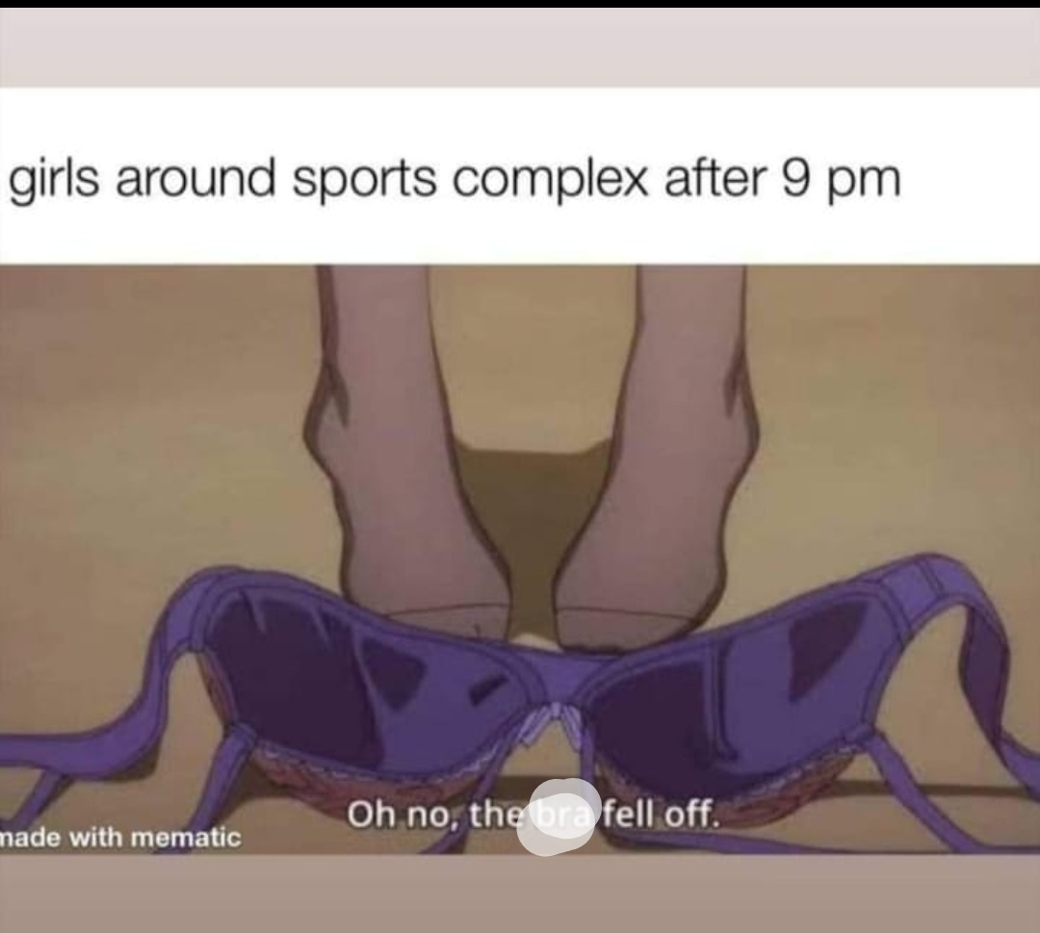
Figure 7 and 8: The Instagram page and criticism
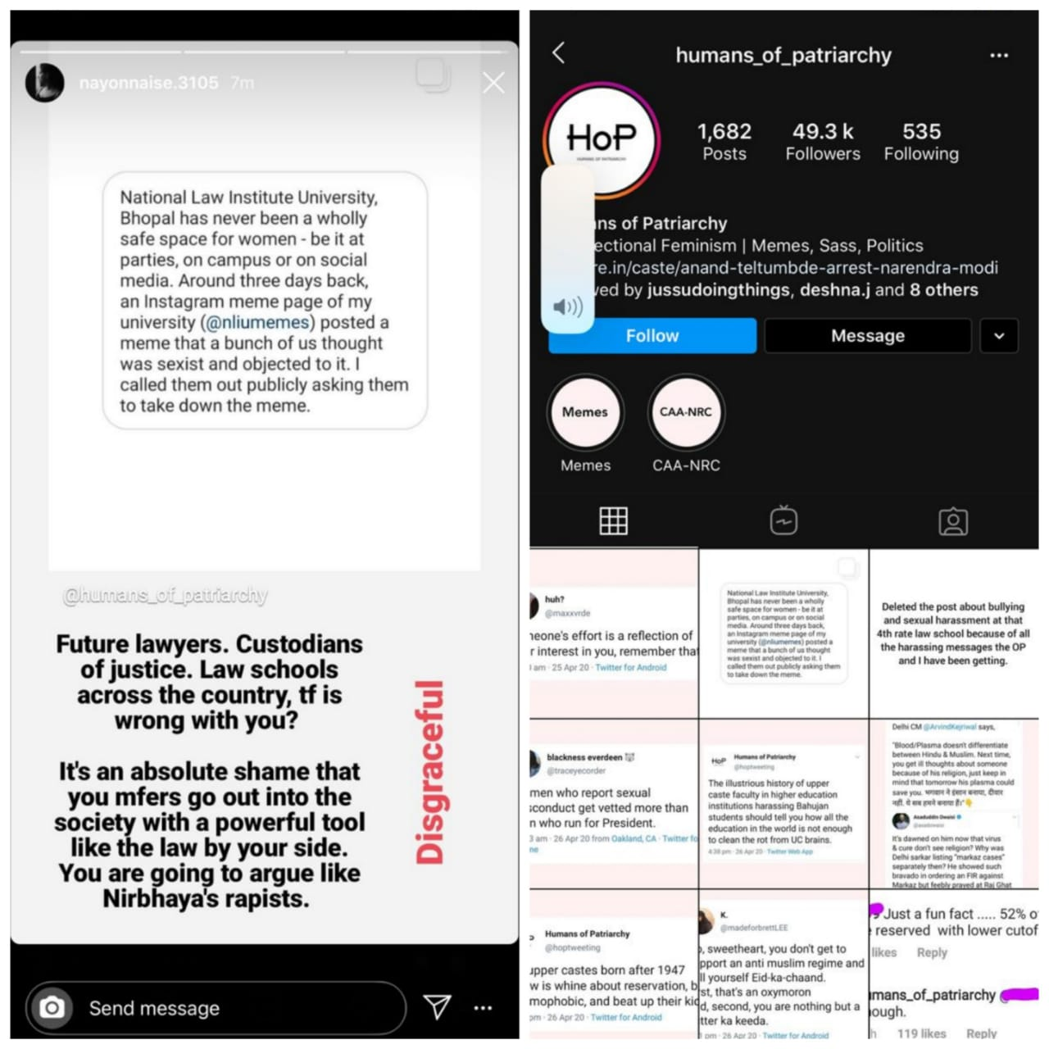
Figure 9 and 10: College girls calling out and ordeals of girls from other colleges
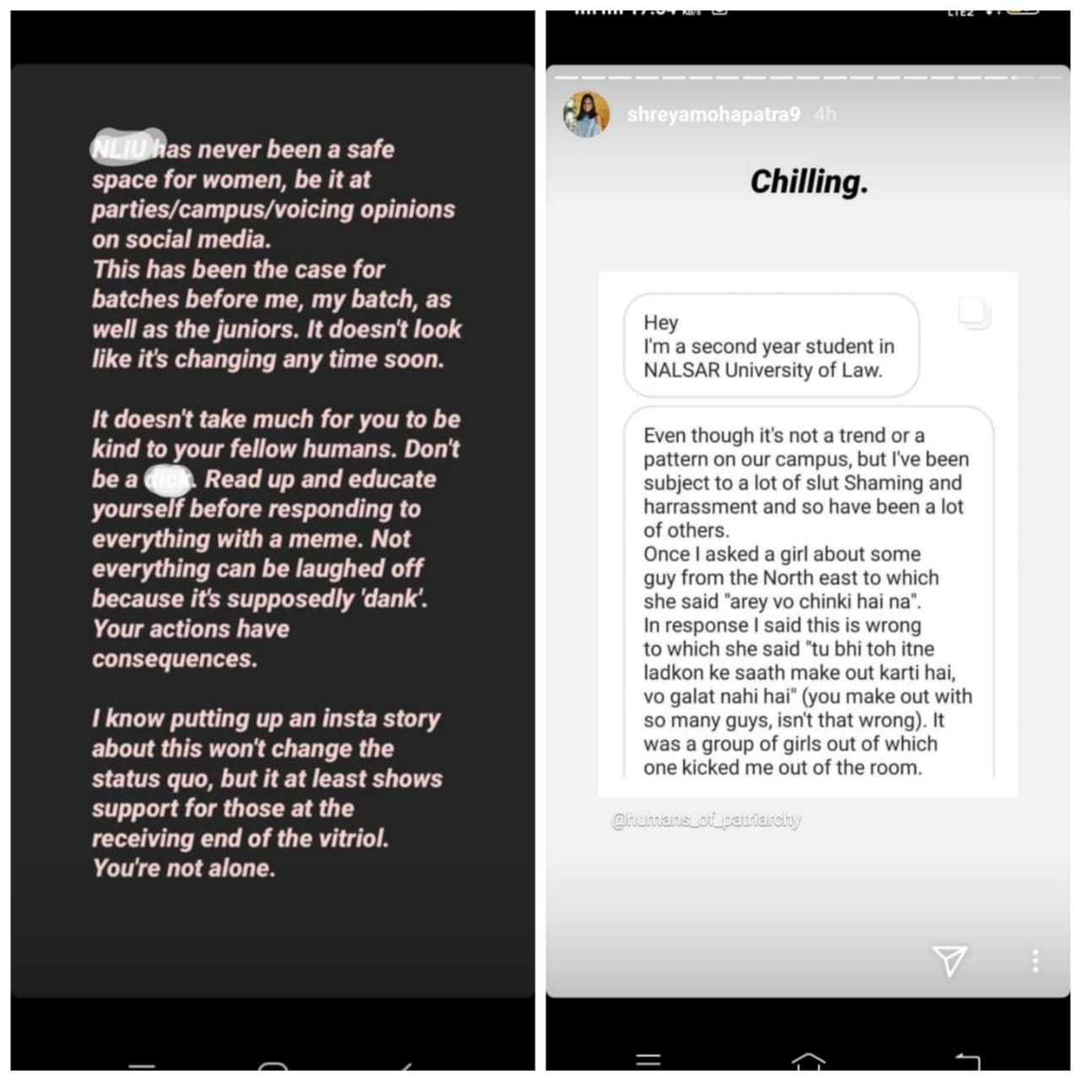
Figure 11: The page admin facing abuse
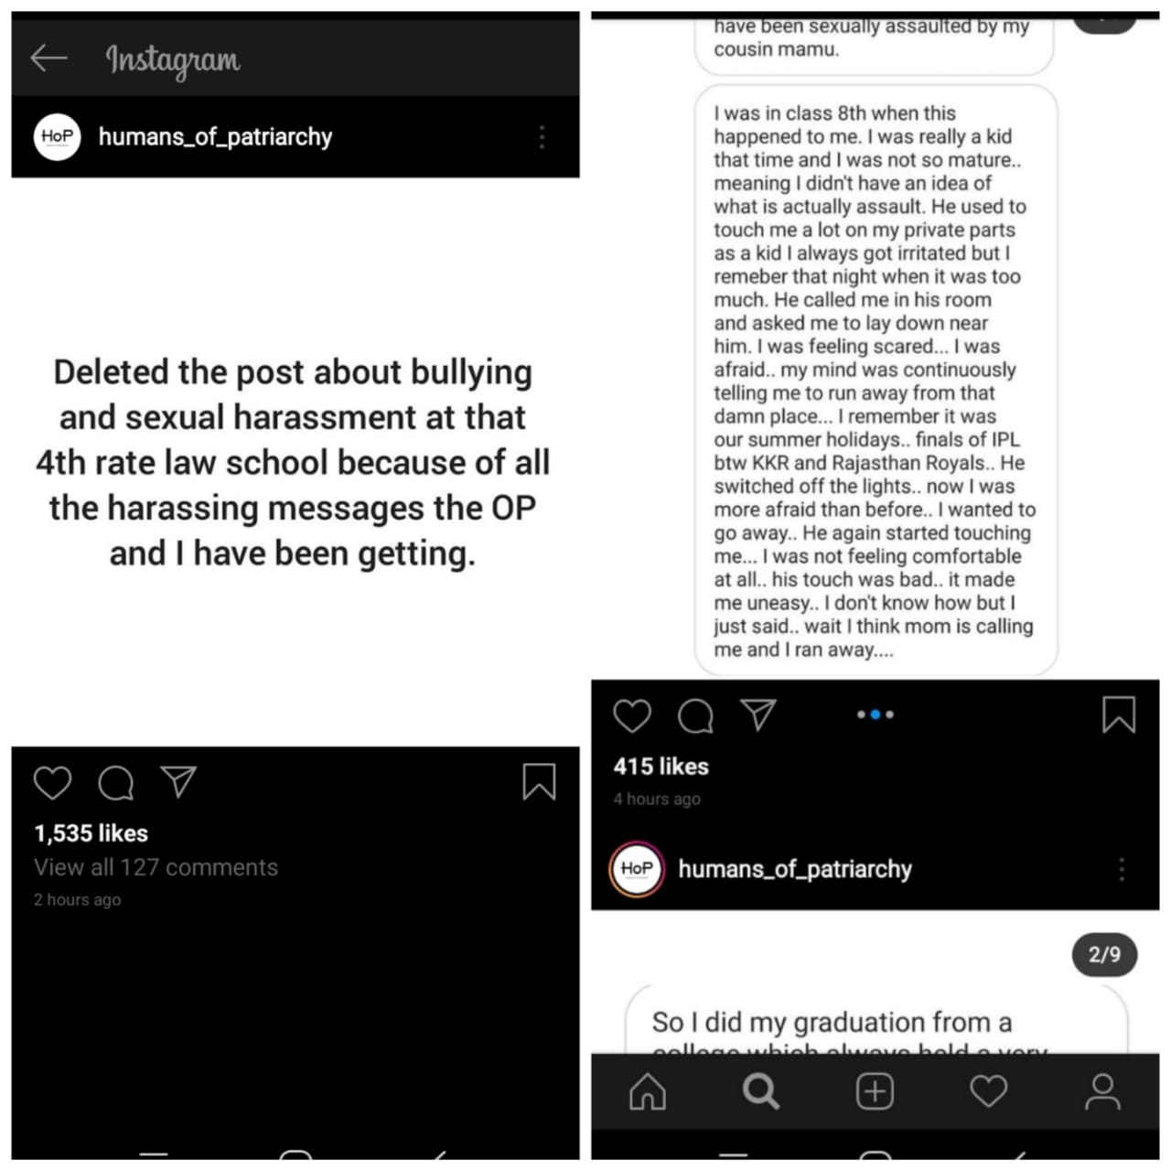
- Memes targeting a particular group
The first meme is targeting a particular caste
The second meme is targeting a gender
The third meme is targeting a particular religion
Figure 12: Memes targeting a caste, sex and religion
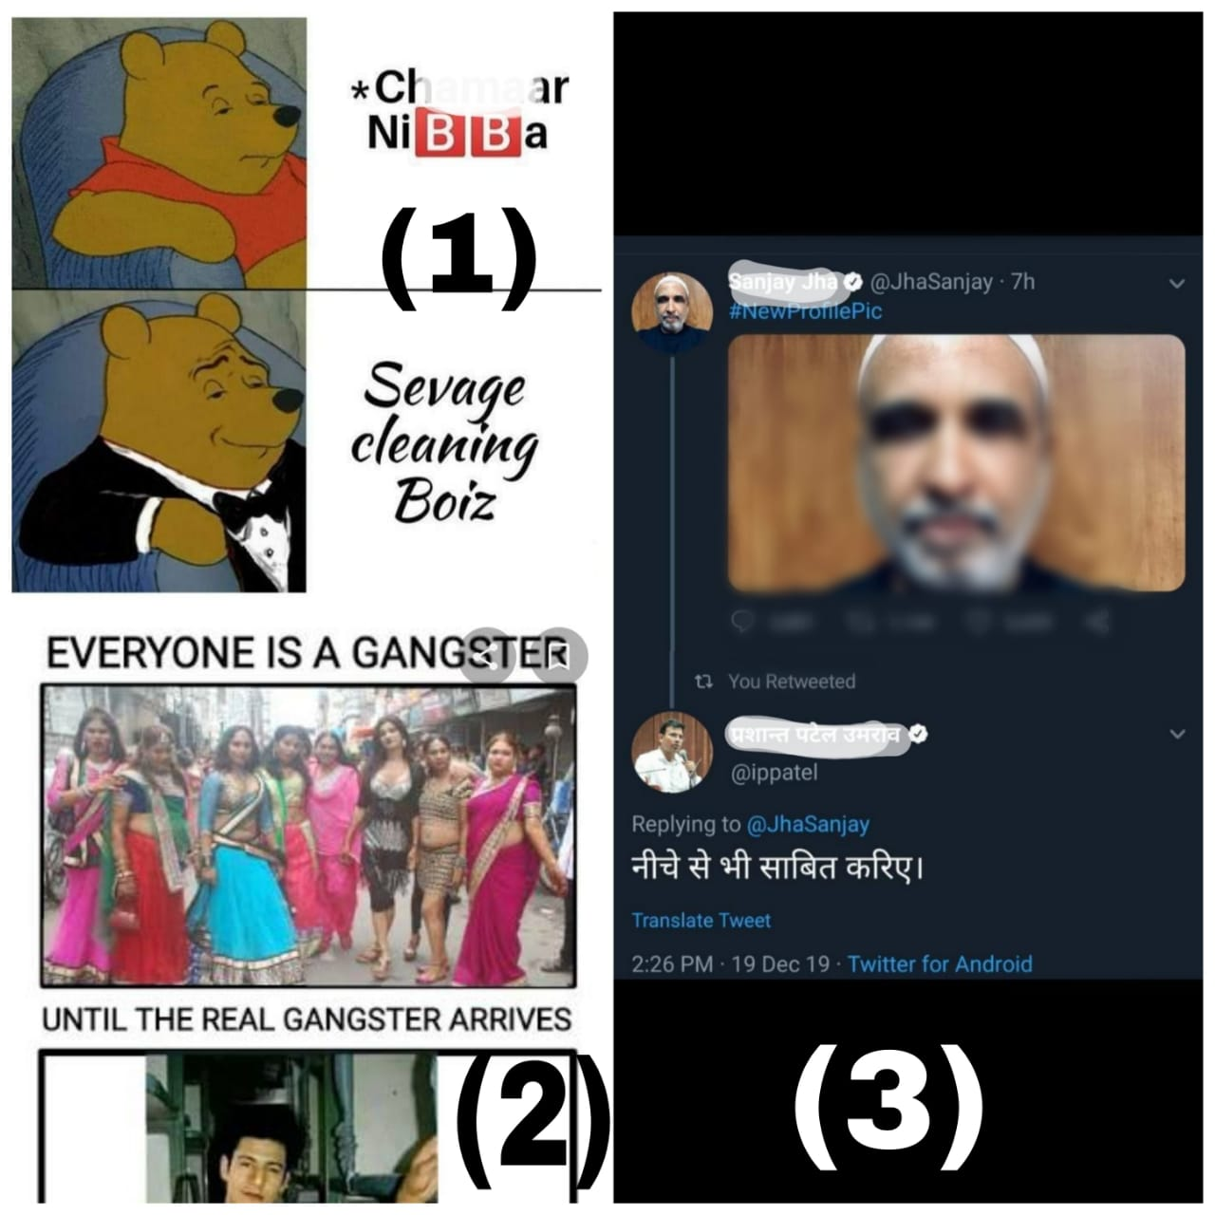

Confession Pages:
This is a new concept and has emerged with the growth of social media. Though all the confession pages follow a different pattern of working, the modus operandi remains the same.
- There is a group of identified or unknown administrators;
- They create a Social Media account with a username depicting its nature of being a confession page, for example, IIT Bombay confessions or BITS Pilani Batch 2020 confessions;
- They have a system where the person who wants to confess either message them personally or fills a google form with the confession;
- The person confessing has the option of being anonymous or reveal his/her identity;
- The confession is later published on the page.
Though this can be a fruitful activity, maximum of the times it is used for notorious purposes. People tend to use this as a medium of personal attack. Very often there are confessions that are aimed at humiliating a person based on his/her physical appearance, background, nature and political affiliations. The worst part of such activity is that such pages are liked and followed by the majority of the college and thus it makes the wounds much deeper. The person becomes the laugh of the town and it has a lasting impact on his school/college life.
Example
The Confession madness at my college
Law College, Bhopal (name changed) has had various confession pages in the past, but the recent activities over social media make us think over its injurious nature. The chaos started in November 2019, when a page with a username @LCB.high af (name changed) was created on Instagram. The page from its birth started posting distasteful confessions. The confessions regularly targeted certain individuals and made fun of them publicly. The page had almost 700 followers which means that almost the entire college was following it. The confessions were attacking individuals based on their love interests, sexual inclination etc. It also had confessions that were demeaning the female students of the college. All this only stopped when the college administration interfered.
The second incident happened during May-June of 2020, there were several Instagram confession pages created during the lockdown. These also had off-putting confessions. With confessions, it also used to have polls, gossips and percentage meters. The majority of them were ugly in taste. Here are some of the examples:
Figure 13: Confessions and questions
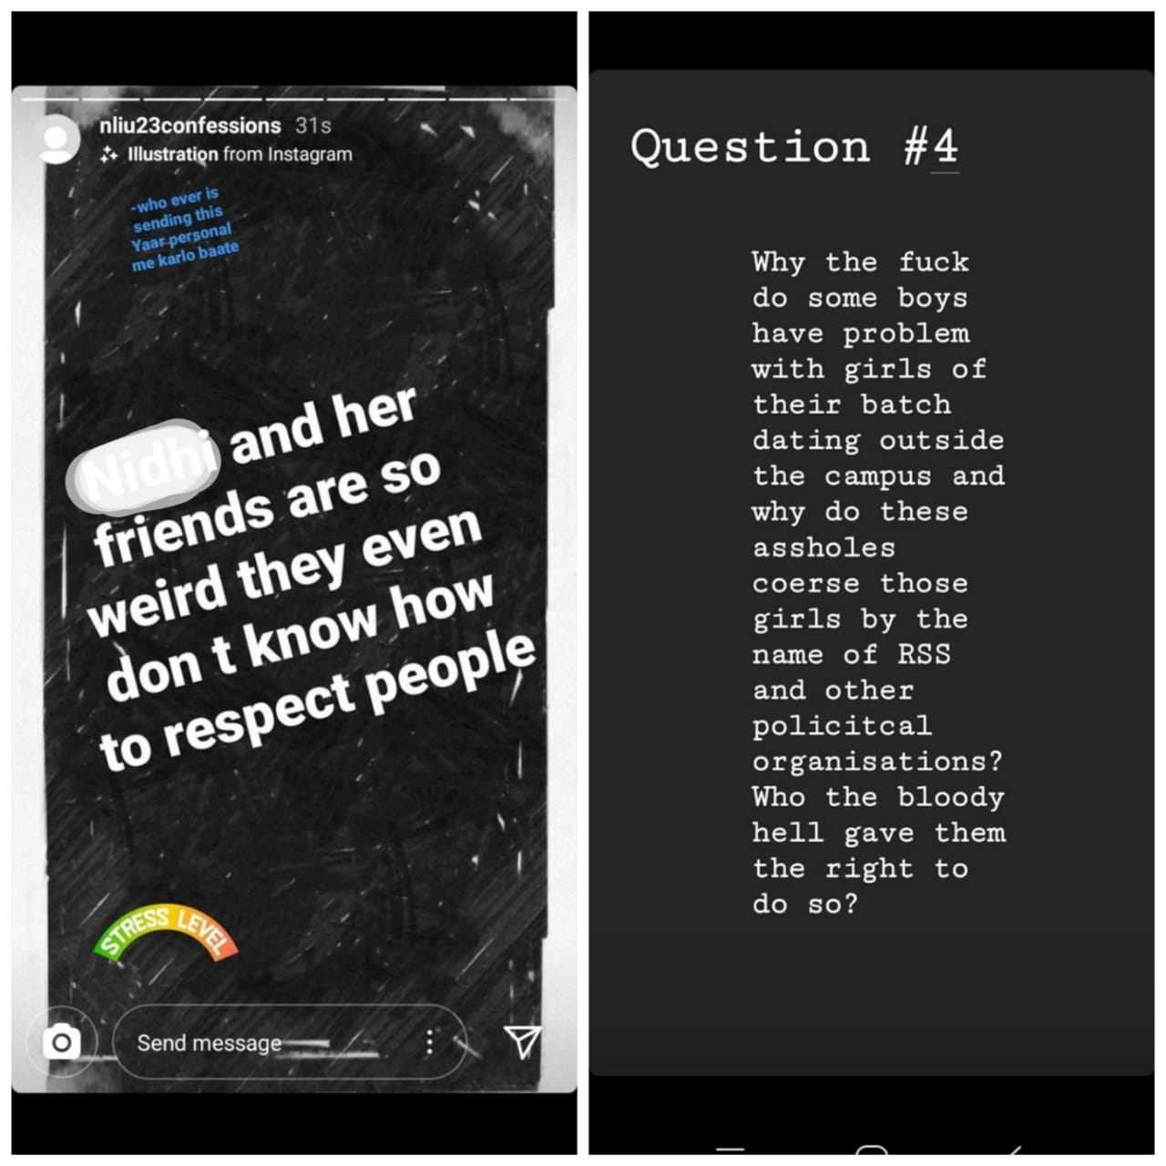
Figure 14: Confessions, opinions, gossips and polls
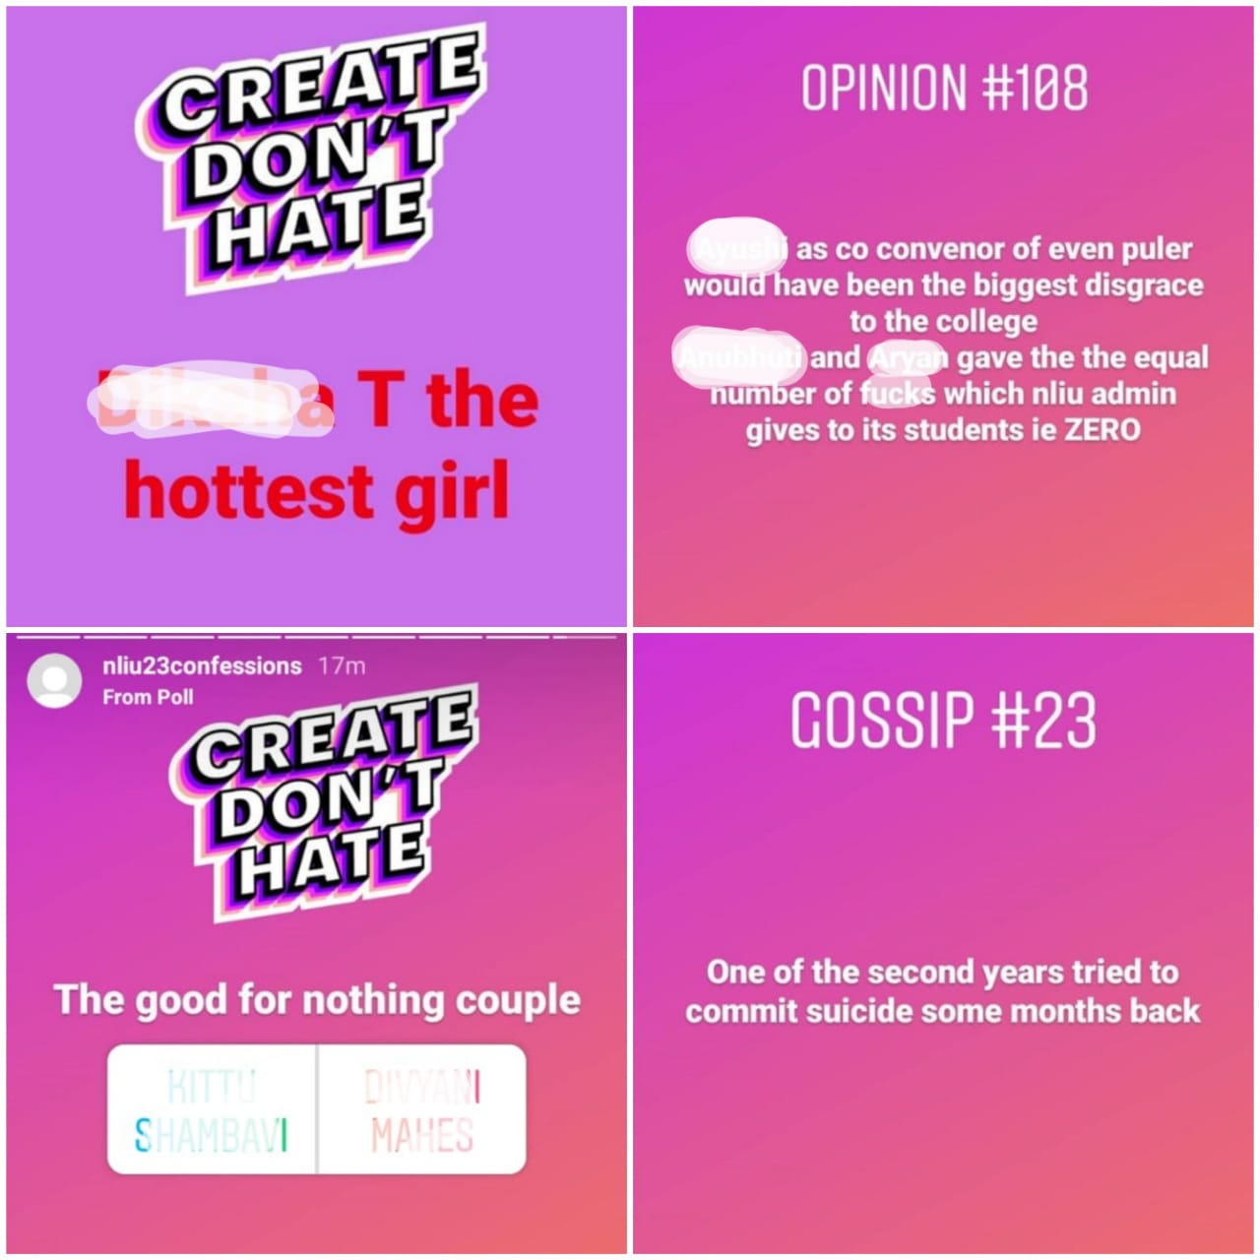

Revenge Porn:
What is revenge porn?
It is the non-consensual sharing of obscene and sexual photos or videos of a person. Generally, the victims are children and teens. This crime has seen an upsurge in the last couple of years due to the increased mobile and data penetration within the Indian mass. Due to this, there is a rise in partners sharing their private images via the internet. Normally, the images or videos are shared with the partner with consent but when relationships get sour, the receiver disseminates it to others without the person's consent. Doxxing, which is the aggravated form of revenge porn involves the circulation of the personal information( E-mail id, contact number and residential address etc.) of the victim along with the image/video.
The term ‘revenge porn’ is very ambiguous because “revenge” may not be the only reason for sharing such information, it may be done out of fun, profit, or merely to show off in front of peers. Also, the word porn is deceptive and the image/video shared might be sexual but not pornographic. The Hon’ble US Court in Austin v. People laid down the ingredients for the offence of revenge porn, these are-
- The image must be sexual in the sense that it should depict intimate body parts of the person, in whole or in part.
- The person should be identifiable through the image.
- The perpetrator was aware that the person shown in the image has not consented to its dissemination.
Reasons for Revenge Porn:
There may be several reasons for revenge porn and doxxing, some of them are:-
- Vengeance- This is the most common reason for revenge porn, here the perpetrator releases private videos of the victim as a punishment for breaking up the relationship. This is done to shame and defame the victim. Most of the times, it is the female who becomes a target of this.
- Glory- At times, such acts of revenge porn are done just to show-off, the perpetrator for some reason enjoys a sense of pride in doing so. The photo or videos might be taken with/without consent but is later put over social media to become popular. There have been various recent incidents when people have put their intimate videos over platforms such as Tik-Tok to gather followers.
- Blackmail- Revenge porn can also be done to blackmail a person for money or favors. The perpetrator may use the image or video to extort official or sexual favors.
Effects on the victim:
Initially, the image or video might have been shared with the perpetrator out of love but once the relationship deteriorates and breaks, some individuals may use this as a tool to destroy their ex-lover's life. Once a video is there in the public domain, it can never be completely removed. The public humiliation and shame the act gets with it may negatively impact the victim psychologically and jeopardize their future relationships. For many victims, the effects of “revenge porn” echo for a long time as many lose their jobs, are forced to change their names, and some feel compelled to go into hiding/ isolation for their safety; most of the victims suffer suicidal thoughts.
Punishment:
As has been mentioned in Chapter 1, India has no dedicated legislation on Cyberbullying and revenge porn, still it is punishable in India through certain legislations. These are-
- Indian Penal Code- Sections 292 “Sale, etc., of obscene books, etc.”, 354-A “Sexual harassment and punishment for sexual harassment”, 354-C “Voyeurism”, 354-D “Stalking” and 509 “Word, gesture or act intended to insult the modesty of a woman” of the IPC.
- Information and Technology Act- Sections 66-C “Punishment for identity theft”, 66-E “Punishment for violation of privacy”, 67 “Punishment for publishing or transmitting obscene material in electronic form”, 67-A “Punishment for publishing or transmitting of material containing sexually explicit act, etc., in electronic form” of the IT Act and 67-B “Punishment for publishing or transmitting of material depicting children in sexually explicit act, etc., in electronic form”.
- Indecent Representation of Women “Prohibition” Act- Section 4 “Prohibition of publication or sending by post of books, pamphlets, etc. containing indecent representation of women” read with Section 6 “Penalty”
- Protection of Children from Sexual Offences Act, 2012- Section 14 “Punishment for using child for pornographic purposes” and Section 15 “Punishment for storage of pornographic material involving child”.
Right to be Forgotten: A way to tackle revenge porn?
“Right to be Forgotten” has been put under Section 27 of the New Personal Data Protection Bill, 2018. As per this, every person shall have the right to restrict or prevent continuing disclosure of personal data involving him/her over the internet. The bill talks about the conditions to be fulfilled for such right to exist, these are (1) data was made with consent but now the consent is withdrawn; or (2) data has served its purpose and is no longer necessary, or (3) data is against the provision of this law. To exercise this right, the concerned person has to make an application to the adjudicatory body, who then will act upon such request.
Currently, the bill is under consideration before the Parliament, but this right has also been recognized by the Indian Judiciary. In 2017, the Karnataka High Court, in the case of Sri Vasunathan v/s The Registrar General & Ors., recognized the principle of “Right to be Forgotten”. Here the petitioner’s daughter had filed a case against her husband for forgery and this information could be found on websites such as Google and Yahoo which would affect his daughter’s relationship with her husband as well as her reputation in the public domain. The Court ordered the masking of such data over the internet, thus recognizing the principle of “Right to be Forgotten”. Recently, the Orissa High Court talked about the need for social media users to have the “Right to be Forgotten”. It showed its displeasure over the current law not being able to curb the menace of revenge porn. The Hon’ble Court said that allowing of such objectionable images/videos on social media is a violation of the victim's Right to Privacy.
Example:
The revenge porn menace at my college
In November this year, a video got viral in our college WhatsApp groups. It was a private video of one of the students from my college. The video went viral like wildfire. Just a day after the incident, all of us knew the name of the victim and the backstory of the video. Though the video was removed from the website, it still is a part of the public domain.
Screenshots
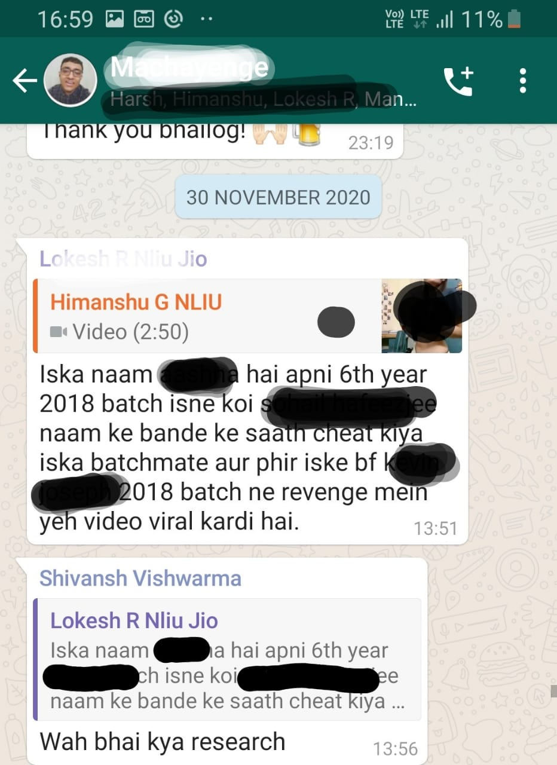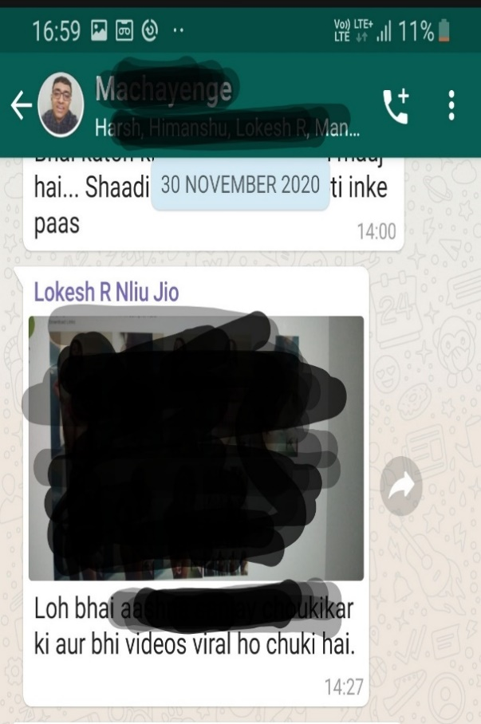

Chapter Three- Research Survey

Introduction about the study:
The present survey was conducted on college students from across India to understand the Cyberbullying and trolling patterns faced by them. 100 college students from 10 states have participated in the survey which was done using the Google Forms software. The areas of concern in the survey were Memes, Confession pages and Revenge Porn. To understand and explore Cyberbullying among college students in cosmopolitan cities, the present study is exploratory in nature. This study is based only on primary data. There was no specific criterion for selecting the samples and students from all backgrounds have filled the questionnaire.

Objectives:
- To find out which social media platforms are popular among college students.
- To understand whether the students have been a victim of online harassment through memes and confession pages.
- To analyze the victimization pattern of Cyberbullying among college-goers.
- To assess the knowledge of revenge porn of college students.
- To find out whether the students discuss the problem of trolling with friends/parents/peers.

Hypothesis:
Almost all the respondents have faced Cyberbullying and trolling through their college meme or confession page.
Research Methodology:
- The present research work is a Descriptive and Analytical Research; and
- It is Non-Doctrinal in nature and;
- It is a Multi-disciplinary Socio-Legal Research.

Research Questions (Questionnaire):
- Which social media platforms do you use?
- Are you aware of the meaning of Cyberbullying?
- Have you ever faced any kind of Cyberbullying or Cyber trolling?
- How often do you face Cyberbullying or online harassment?
- Have you discussed the issue of online harassment with your friends/parents/peers?
- Does your college have a meme or confession page/group on social media platforms such as Facebook or Instagram etc.?
- Are those pages/groups troll or offensive?
- Have you ever been harassed or trolled on public platforms through these memes or confession pages?
- Should these pages/groups be allowed to function?
- Do you know what is revenge porn?
- Have you or someone you know faced revenge porn?
- How do you face and manage trolls and online abuses?

Sample for the study:
The universe of the study comprises of college students from various disciplines of education such as Engineering, Law and Medical etc.(Figure 15). The Samples are from various states of India( Delhi, Maharashtra, Madhya Pradesh, Chhattisgarh, Uttar Pradesh, Rajasthan, Uttarakhand, West Bengal, Haryana and Gujarat). Students from the states of Madhya Pradesh, Maharashtra and Delhi were the major contributors to the survey. Students from 12 Indian cities (Delhi, Mumbai, Nagpur, Sagar, Raipur, Kanpur, Lakshmangarh, Roorkee, Kharagpur, Bhopal, Indore and Kurukshetra) (Table 1) have taken the survey, However, a small sample of college students are from the cities of Lakshmangarh, Roorkee and Kharagpur. (Table 1) A total of 100 respondents have taken the survey from which 52 are female, 46 are male while 2 of them did not prefer to say their gender. (Figure 16) There was no discrimination made among the participants based on their culture, religion, ethnicity, language, community, caste and religion.
Table I: The educational background and institution name of samples(n=100)
Serial Number | Multi-discipline | Law | Medical | Engineering and Management | School and Others
1 | Gargi College | Dharmashastra National Law University, Jabalpur | Government Medical College, Nagpur | Indian Institute of Information Technology, Nagpur | Ryan International School, Bhopal
2 | St.Vincent Pallotti college of engineering and technology, Nagpur | Dr. Harisingh Gour Central University, Sagar | Shivaji College, Nagpur | Rajiv Gandhi College of Engineering and Research, Nagpur | National Institute of Design, Ahmedabad
3 | School of Excellence, Bhopal | Hidayatullah National Law University, Raipur | People's College of Dental Sciences, Bhopal | National Institute of Technology, Raipur | Shri Datta Meghe Polytechnic, Nagpur
4 | Indian Institute of Technology, Roorkee | National Law Institute University, Bhopal |  | Shri Ramdeobaba College of Engineering and Management, Nagpur | Rajiv Gandhi Proudyogiki Vishwavidyalaya (Polytechnic Wing), Bhopal
5 | Indian Institute of Technology, Kanpur |  |  | Delhi Technical University, Delhi | NYSS Datta Meghe College, Nagpur
6 | Mumbai University, Mumbai |  |  | Dr. Panjabrao Deshmukh Institute of Management Technology, Nagpur
7 | VMV Commerce jmt arts & jjp science College, Nagpur |  |  | National Institute of Technology, Kurukshretra
8 |  |  |  | Cummins College Of Engineering For Women, Nagpur
9 |  |  |  | VNIT, Nagpur
10 |  |  |  | Institute of Engineering & Technology, DAVV, Indore
Figure 15: Percentage of students from a particular stream(n=100)
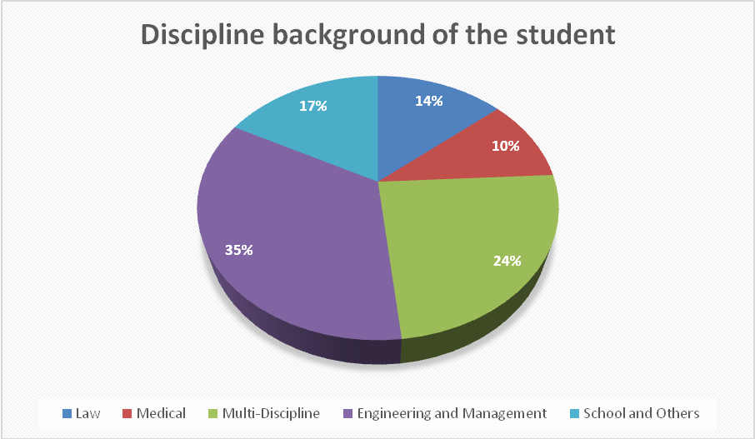
Figure 16: Gender of the samples(n=100)
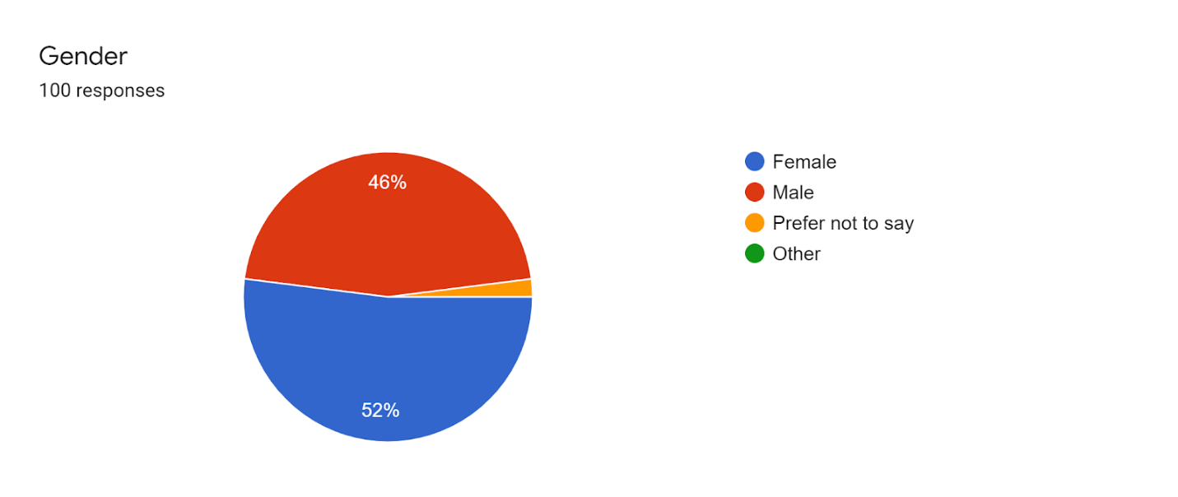
Table II: Gender of the samples(n=100)
Serial No. | Gender | Frequency(Persons) | Percentage
1 | Male | 46 | 46
2 | Female | 52 | 52
3 | Prefer not to say | 2 | 2
4 | Other | 0 | 0

Research Tool:
The primary data was collected using the questionnaire method. Due to the COVID-19 Pandemic and physical limitations, the study was conducted online using the Google Form.

Data collection:
In this study, the data collected is of the Primary category.

Results and Analysis:
- Social Media usage
Figure 17: Social Media usage among college students(n=100)
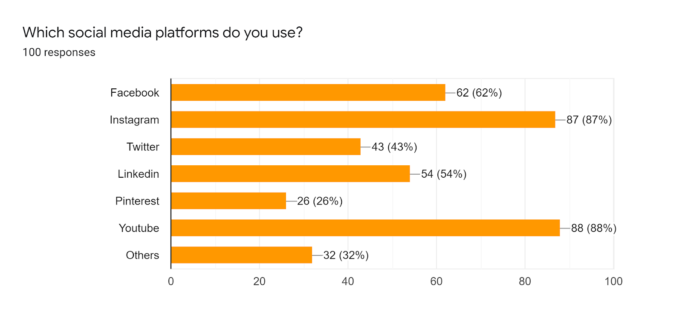

Figure 17 shows the popularity of Social Media applications among students. It is found that YouTube is the most popular social media platform with 88 out of 100 students using it. Instagram grabbed the second spot with 87%. As expected, platforms such as Facebook and Instagram is popular with the youth, as most of the trolling and mischief happens on Facebook and Instagram. More than half of the students use LinkedIn and there are no major cases of Cyberbullying through it. Surprisingly, Twitter was lagged much behind here, with only 43% of students using it.
- Cyberbullying
Figure 18: Awareness about Cyberbullying(n=100)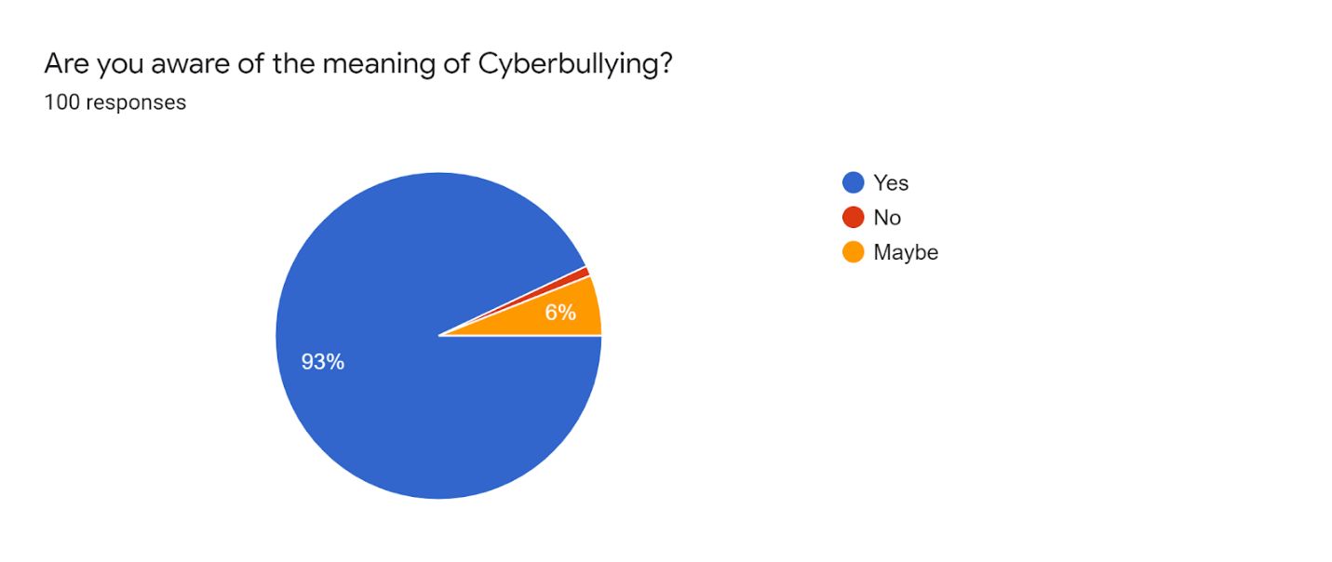Figure 18 shows awareness among college students regarding Cyberbullying. The study shows that about 93 out of 100 students are aware of the meaning of Cyberbullying. It is very pleasant to see that such a majority of the students are having the awareness about Cyberbullying.

Figure 19: Experience of Cyberbullying and Cyber trolling(n=100)
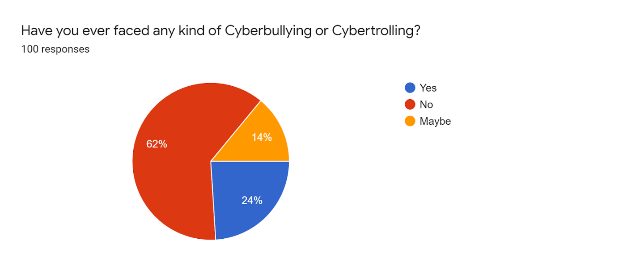
Figure 19 depicts the experience of cyberbullying among college-goers. According to this almost 38% of the students have faced Cyberbullying and Cyber trolling in some form or the other. The number of victims of Cyberbullying is moderately less than what was expected out of the study.
Figure 20: Often ness of Cyberbullying(n=100)
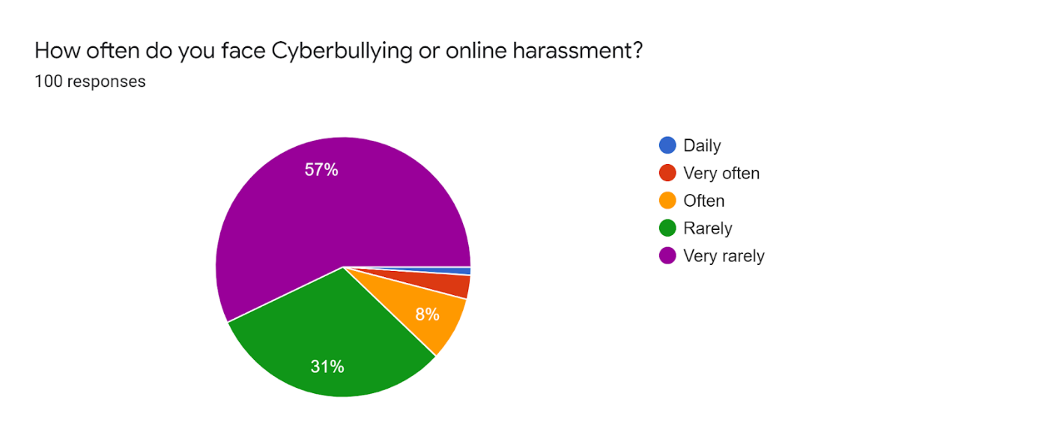
Figure 20 gives a picture of how often do the respondents face Cyberbullying. A majority of 88% of survey takers rarely face Cyberbullying. It is found that 1 out of 10 students are facing trolling and bullying regularly.
Figure 21: Discussion with parents(n=100)
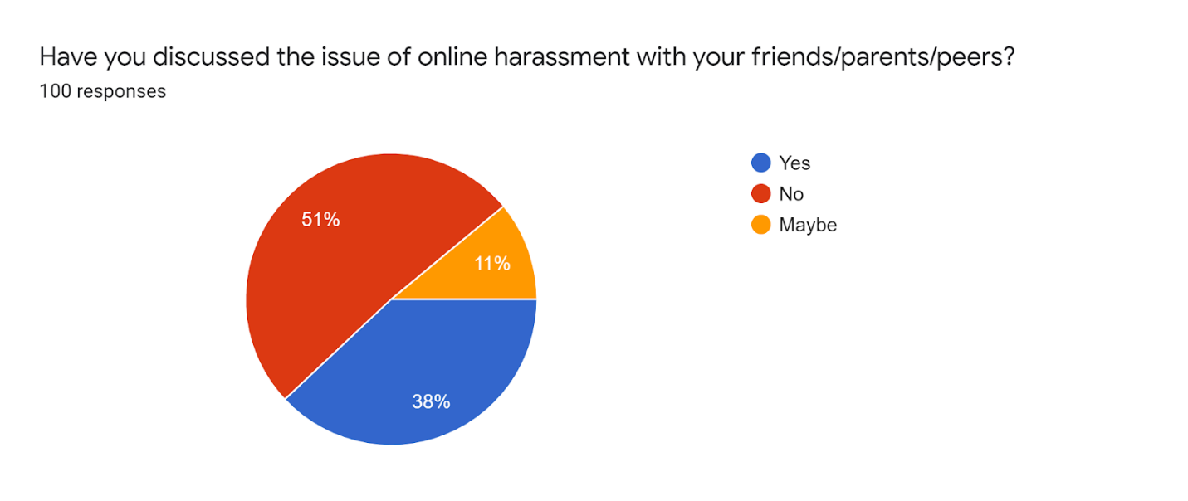
Figure 21 describes whether the students have discussed the issue of Cyberbullying with their parents/peers or friends. Nearly 50% of the respondents have at least once have discussed the issue of Cyberbullying with their known ones. It is very astounding to record that though almost all of them are aware of the issue, still most of the respondents have not openly discussed it.
- Memes and confession pages
Figure 22: College having meme and confession pages(n=100)
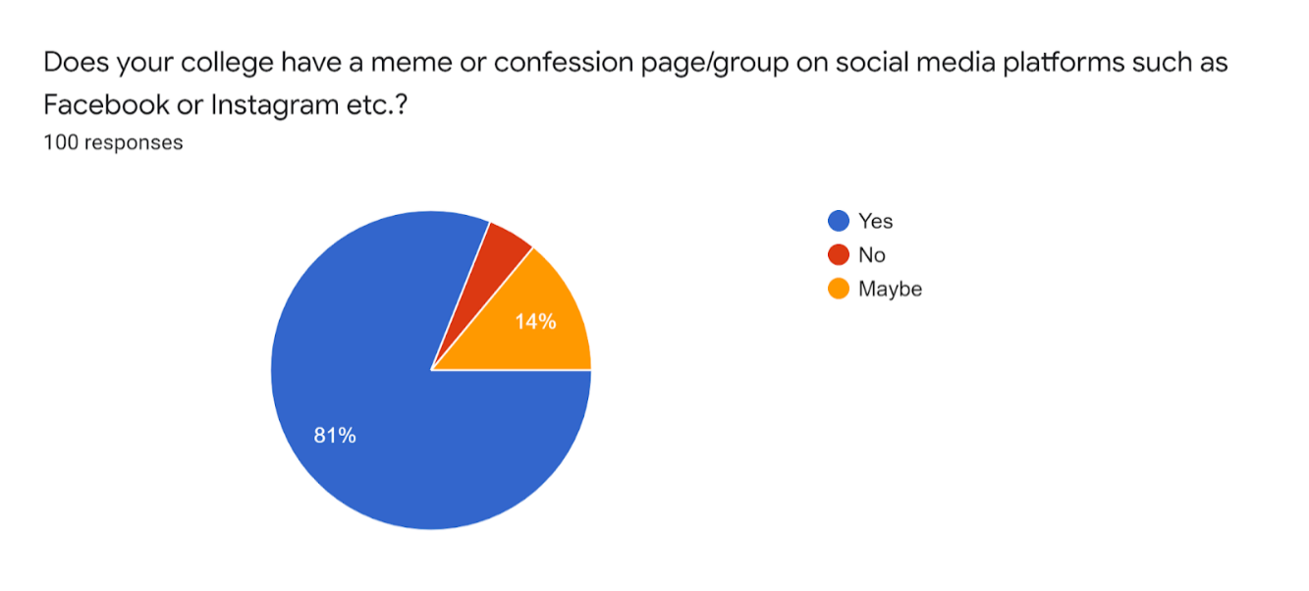
Figure 22 shows the existence of meme and confession pages in colleges. 9 out of 10 colleges have a meme or confession page.
Figure 23: Nature of the meme and confession pages(n=100)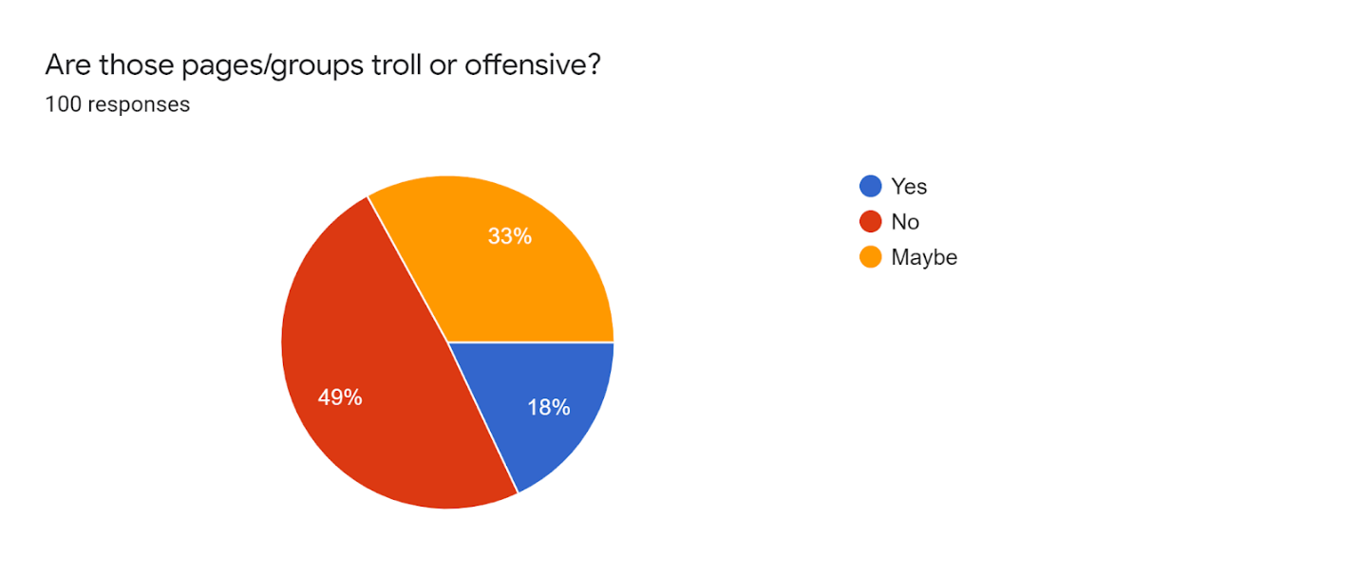Figure 23 talks about the nature of the meme/confession pages in these colleges. Half of the respondents felt that these pages were troll in some or the other way.
Figure 24: Harassment faced through meme and confession pages(n=100) 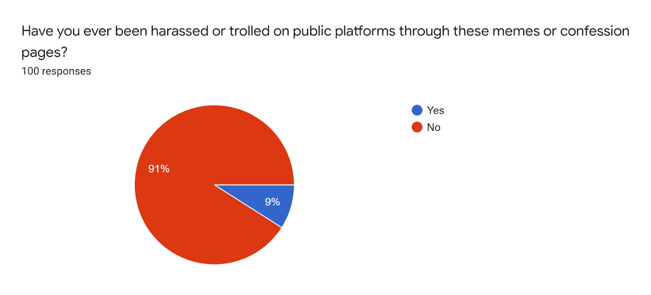Figure 24 depicts the harassment faced through meme and confession pages. About 9 of the respondents have faced trolling on social media through these meme/confession pages. Most of them (91%) have not experienced anything as such.
Figure 25: Should these pages be allowed to function(n=100)
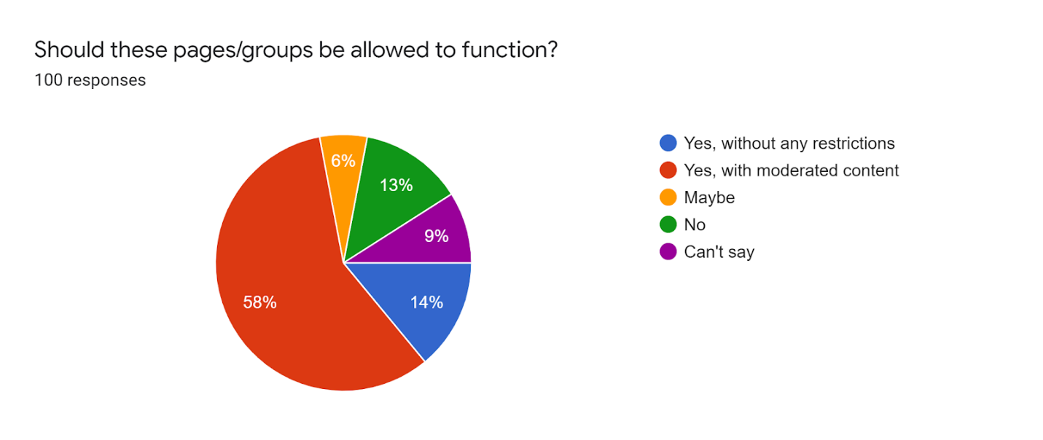
Figure 25 talks about the opinion of students on these meme/confession pages. A majority(58%) of the respondents felt that there is a need for checks and balances on these social media pages. Some students(14%) felt that such pages should be allowed without any restrictions. About 9 students were not sure about the answer to the question, this is because they may not be very active on social media.
- Revenge Porn
Figure 26: Awareness about revenge porn(n=100) 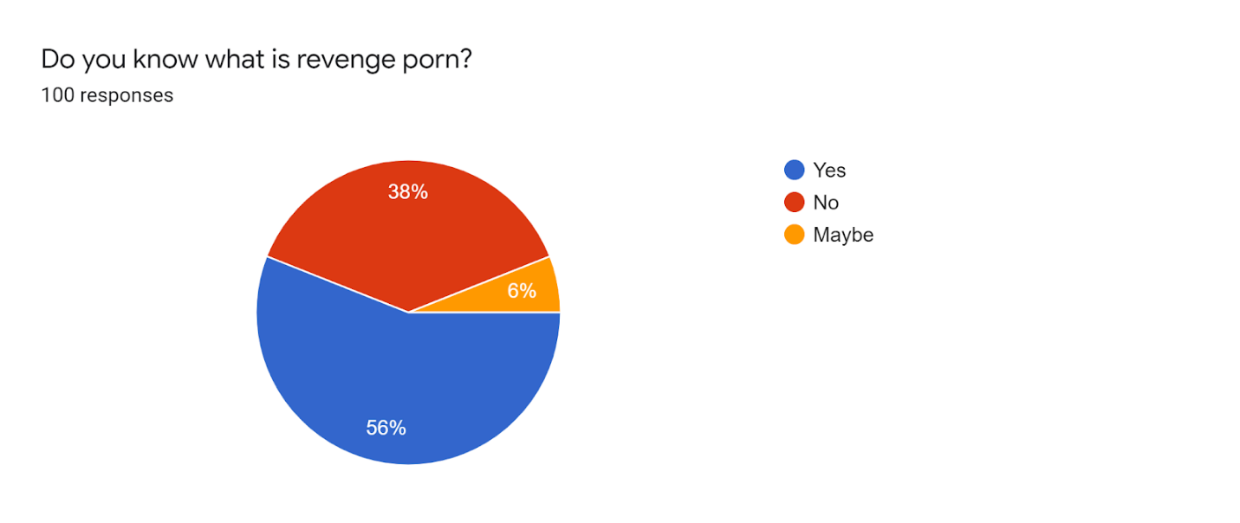Figure 26 provides information regarding the awareness about revenge porn among college students. From the above result, it can be inferred that more than half of the respondents are having an idea about revenge porn. Considering the seriousness of the issue, the number is still less.
Figure 27: Experience of revenge porn(n=100)
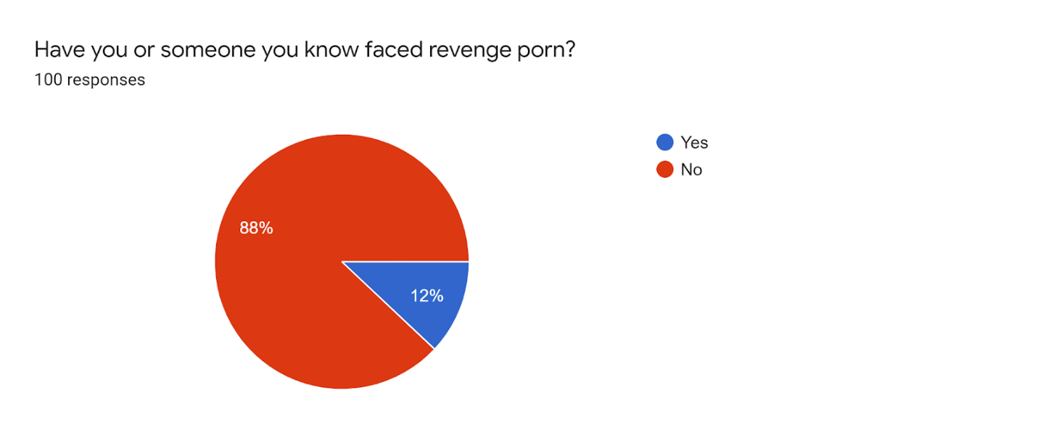
Figure 27 shows the number of students who have faced revenge porn. It is dreadful to find that in a small sample of 100 students, 12 have themselves/or know someone who has become a victim of revenge porn. With these statistics, we can understand how colossal the problem is.
Table III: How do students respond to Cyberbullying (n=100)
Serial No. | Response | Frequency(Persons) | Percentage
1 | Report the post, unfollow the page and block | 12 | 23%
2 | Ignore them | 13 | 21%
3 | I have not experienced this | 9 | 16%
4 | Contact Cyber police and tell my friends | 4 | 8%
5 | Talk to my family | 4 | 8%
6 | By reverse trolling and abusing them back | 3 | 5%
7 | Complain to College officials | 3 | 5%
8 | By spreading digital education | 3 | 5%
9 | Talk to the page Admin | 3 | 5%
10 | Delete my social media account | 2 | 4%
Total |  | 56 | 100%

Table 3 provides information about how students respond to cyberbullying. 23% of the respondents favored unfollowing, reporting and blocking social media as a solution for Cyberbullying. 21% of the respondents believe in ignoring such bullying and trolling. 16% of respondents do not have any such experience. A moderate 13% felt that talking to friends and family and reporting such acts to the cyber police might help. 5% of the respondents preferred giving it back by reverse trolling and abusing. A minority of 2 students believed that deleting their social media is the only solution to this problem.

Chapter Four-Suggestions and Conclusions

Suggestions:
Cyberbullying (including cyberbullying through memes and confession pages)-
- The best way to respond to bullying and trolling is to ignore them. Generally, the perpetrators look for the victim's reaction for their further course of action, thus not responding to such acts is the best way to curb the power of the perpetrator. In the above study, there were a few respondents(5%) who felt that reverse trolling can be a solution, but in reality, it only acts as an incentive to the perpetrator to further harass the victim. 44% of the students did agree that ignoring and blocking such pages and people is the best solution.
- One of the key ways to keep one’s legal case strong is to keep the evidence safe. The victims can do it in many ways. If there is a mail, post or comment which goes against the law, then the victim can take a screenshot of it. If the material is a video then a screen recording application can help. 8% of the respondents felt that making a complaint to the Cyber Police can help them.
- Most of the social media applications these days provide the feature of blocking and reporting the accounts which are troublemakers. After a certain number of blocks are reached, the social media operator themselves ban the person. One out of four(25%) respondents felt that blocking the perpetrator can help in ending the problem.
- In cases of confession pages, reaching out to the college authorities can help. The authorities may then give warnings to the anonymous admin of the page which may lead to the withdrawal of such content over the web. But only a minority(5%) of the respondents thought this to be a viable solution.
- Nowadays, it is inevitable for a person to do without social media but one should be smart enough to know what information should go onto the screen and what shouldn’t. Sensitive information and media should not be uploaded on social media. Also, one should keep their passwords and OTPs protected. They should regularly change passwords to keep their accounts secure.
- As Cyberbullying through memes and confession pages fall within the definition of ragging provided by the University Grants Commission, the Anti-Ragging committees should take cognizance of the acts of Cyberbullying in colleges.
Revenge Porn
- Unfortunately, there is no specific law in India to combat revenge porn. The current legislation and codes are inadequate in dealing with such offences. Apart from revenge porn, there are its aggravated forms such as doxxing and downstream distribution(dissemination by a third party) which are not covered properly under any law. The country needs a law to combat the problem of revenge porn and downstream distribution
- Revenge porn unlike most of the offences can have a lifelong impact on the victim. The State should focus on psychological regeneration of the victim. This can be done through counselling sessions and victim compensation schemes.
- The authorities should act speedily in removing the content from the web to minimize the damage. Adult websites should also have a system of checks and balances through which only intended videos should feature on their portal. They should also make sure that the videos which have been made to be removed by the authorities are not reposted on their website.

Conclusion:
Computer Technology is a blessing for mankind. though a boon, it is a double-edged sword, we are always under the risk of its erroneous exploitation. Cyberbullying is increasing in India at an ever high speed and the credit for this goes to increasing access to technology, dirt-cheap internet plans, availability of mobiles and electronic devices cheaply, and political support for digital India.
The youth in India are the major targets of trolls and bullies. With changing times, the ways of Cyberbullying have improvised. Nowadays, memes and confession pages are the major tools of harassing a person in schools and colleges. The paper has explained how such meme and confession pages operate and how ruinous these activities can be.
As per our study, almost all the respondents have a meme or confession page belonging to their college and most of them are on Instagram and Facebook. Though unlike the premise of the study, most of these pages were positive in their content and only a moderate of 9% of the students have had faced cyberbullying through these pages. But still, more than half of the respondents believed that such pages should be moderated and should not be given the liberty to post anything. A good number of students were aware of the meaning of revenge porn, but it was petrifying to know that 12 out of 100 students have encountered revenge porn.
These acts of Cyberbullying are covered under the Indian jurisprudence but not completely. The IPC and IT Act have provisions governing such acts but these are not sufficient. Various wrongs such as doxxing and downstream distribution have not been covered under the law. Thus, there is a need for a new set of legislations to curb such offences. The Right to be forgotten has been mentioned in the New Data Protection Bill, 2018, but it is still pending before the legislature. Apart from legislation, there is a need to sensitize these issues among the students at the college level. This may be done by the administration or the student's body. With a careful approach, we can use technology for everyone’s good.

Bibliography:
Books and Articles
- Principles of cyberbullying research: Definitions, measures, and methodology by Smith, P. K., Del Barrio C., & Tokunaga.
- Systematic review of empirical studies on cyberbullying in adults: What we know and what we should investigate by Jenaro C., Flores N., Frías C.P.
- The Cyber Effect: A Pioneering Cyberpsychologist Explains How Human Behaviour Changes Online by Aiken M. UK London: Hachette
- On the overlap between victimization and offending: A review of the literature by Jennings W.G., Piquero A.R., & Reingle J.M
Online Sources
- https://www.livemint.com/Leisure/lpQCFqjgETbXachoWRxysO/Cyber-bullying-Nip-it-in-the-bud.html
- https://www.timesnownews.com/sports/cricket/article/held-for-issuing-rape-threats-to-ms-dhonis-daughter-ziva-dhoni-gujarat-minor-brought-to-ranchi-for-interrogation-csk-ipl/667965).
- https://www.thequint.com/entertainment/bollywood/srk-aamir-salman-studios-among-ones-to-file-suit-against-arnab-navika
- https://folkire.com/blog/the-mystery-behind-angel-priya-unlocked/,
- https://www.indiatoday.in/lifestyle/health/story/43-per-cent-indians-suffering-from-depression-study-1705357-2020-07-28, (last visited 3 Dec, 2020).

Student, NLIU Bhopal
Smith, P. K., Del Barrio C., & Tokunaga, R.S. (2013). Principles of Cyberbullying Research: Definitions, Measures, and Methodology. 26-28, (New York: Routledge, 2013)
Shweta Taneja, Cyber bullying: Nip it in the bud, LIVE MINT, 26 May 2015, https://www.livemint.com/Leisure/lpQCFqjgETbXachoWRxysO/Cyber-bullying-Nip-it-in-the-bud.html
Psychology Wiki, https://psychology.wikia.org/wiki/Cyber-bullying, (last visited 1 December, 2020).
Jenaro C., Flores N., Frías C.P., Systematic Review Of Empirical Studies On Cyberbullying In Adults: What We Know And What We Should Investigate., 113–122, (Aggress. Violent Behav. 2018)
Ibid at 153.
Aiken M. UK London: Hachette, The Cyber Effect: A Pioneering Cyberpsychologist Explains How Human Behaviour Changes Online, pp. 119–38, Aug 18.
TN Desk, Held for issuing rape threats to MS Dhoni's daughter Ziva, Gujarat minor brought to Ranchi for interrogation, TIMES NOW, (Updated Oct 16, 2020 | 06:59 IS), https://www.timesnownews.com/sports/cricket/article/held-for-issuing-rape-threats-to-ms-dhonis-daughter-ziva-dhoni-gujarat-minor-brought-to-ranchi-for-interrogation-csk-ipl/667965).
QUINT ENTERTAINMENT, SRK, Aamir, Karan Among Studios to File Suit Against Arnab, Navika34 Bollywood producers have filed a suit in the Delhi High Court against 2 news channels, THE QUINT, 13 Oct 2020, 1:51 AM IST, https://www.thequint.com/entertainment/bollywood/srk-aamir-salman-studios-among-ones-to-file-suit-against-arnab-navika
National Commission for Women, http://ncw.nic.in/notice/gender-sensitization-module-gender-sensitization-and-legal-awareness-programme-collaboration, (last visited on 28 Nov, 2020)
. More Kids are Online. But Indian Parents are Finally Taking Stock: Intel Study. The Indian Express. 2015. Available from: http://www.indianexpress.com/article/technology/tech-news-technology/more-kids-are-online-but-indian-parents-are-finally-taking-stock-intel-study/
Hinduja. S., & Patchin, J.W, Bullying, cyberbullying, and suicidE, 206–21. Arch Suicide Res, 14, 2010.
Nandini Sharma, What Was Agrima Joshua’s Stand-Up About And Why You Should Care About It?, DU EXPRESS, (last visited 2 Dec, 2020), https://duexpress.in/what-was-agrima-joshuas-stand-up-about-and-why-you-should-care-about-it/.
FOLKIRE, https://folkire.com/blog/the-mystery-behind-angel-priya-unlocked/, (last visited 2 Dec, 2020).
LIVEMINT, https://www.livemint.com/industry/telecom/active-users-tally-jio-gains-2-5-mn-subscribers-in-july-as-airtel-vodafone-idea-slip-11603001279976.html, (last visited 2 Dec, 2020).
Patchin J, Cyberbullying data – Cyberbullying Research Center, CYBERBULLYING.ORG, https://www.cyberbullying.org/2016-cyberbullying-data.
Jennings W.G., Piquero A.R., & Reingle J.M, On the overlap between victimization and offending: A review of the literature. Aggress, (Violent Behav. 16-26, 2012).
INDIA TODAY, https://www.indiatoday.in/lifestyle/health/story/43-per-cent-indians-suffering-from-depression-study-1705357-2020-07-28, (last visited 3 Dec, 2020).
. Finne J., Roland E., & Svartdal F.(2018). “Relational rehabilitation: Reducing the harmful effects of bullying, 38:352–367, (Nord. Stud. Edu, 2018).
STATISTICA.COM, https://www.statista.com/statistics/751005/india-share-of-internet-users-by-age-group/#:~:text=Around%2054%20percent%20of%20the,the%20total%20internet%20user%20base., (last visited 23 Nov, 2020).
CONNECT TO INDIA, https://www.connectedtoindia.com/how-much-time-do-indians-spend-online-7997.html#:~:text=Studies%20showed%20that%20Indian%20adults,%25)%20was%20on%20mobile%20devices.&text=and%20casino%20games,India%20is%20quickly%20outgrowing%20China%20as%20one%20of%20the%20leading,the%20world%20for%20Internet%20consumption, (last visited 25 Nov, 2020).
GS STATS COUNTER, https://gs.statcounter.com/social-media-stats/all/india, (last visited 1 Dec, 2020).
WIKIPEDIA, https://en.wikipedia.org/wiki/Bois_Locker_Room, (last visited 1 Dec, 2020).
STATISTICA.COM, https://www.statista.com/statistics/235850/value-of-the-gaming-industry-in-india/#:~:text=The%20market%20value%20of%20India's,new%20job%20opportunities%20by%202022., (last visited 2 Dec, 2020).
NEWS EXPRESS.COMhttps://www.newindianexpress.com/lifestyle/health/2020/jun/17/87-per-cent-indian-adults-believe-online-gaming-affects-well-being-survey-2157675.html, (last visited 2 Dec, 2020).
Ibid
CYBER CRIME COMPLAINTS, https://www.cybercrimecomplaints.in/thread/rummy-circle-fraud/, (last visited 2 Dec, 2020).
REGINA MIHINDUKULASURIYA, More dislikes than likes for Modi live streams — what stats show and how BJP sees itThe live stream videos on PM Modi’s official YouTube channel seem to be facing a new response trend — dislikes dominating likes, THE PRINT, 7 September, 2020 3:19 pm IST, https://theprint.in/india/more-dislikes-than-likes-for-modi-live-streams-what-stats-show-and-how-bjp-sees-it/497537/
GRITDAILY, https://gritdaily.com/tiktoks-violent-video-problem-is-nothing-new-to-social-media/, (last visited 3 Dec, 2020).
Indian Penal Code, 1860, Section 292 A.
Indian Penal Code, 1860, Section 354 A.
Indian Penal Code, 1860, Section 354 C.
Indian Penal Code, 1860, Section 354 D.
Indian Penal Code, 1860, Section 503.
Indian Penal Code, 1860, Section 507.
Indian Penal Code, 1860, Section 499.
Information and Technology Act, 2000, Section 66 C .
Information and Technology Act, 2000, Section 66 D.
Information and Technology Act, 2000, Section 66 E.
Information and Technology Act, 2000, Section 67 B .
Sharat Babu Digumarti v. Govt. of NCT of Delhi, 2016 SCC OnLine SC 1464,
State of West Bengal v AnimeshBoxi, C.R.M. No. 11806 of 2017, GR/1587/2017.
Prakhar Sharma v. The State of Madhya Pradesh, MANU/MP/0915/2017
WIKIPEDIA/MEME, https://en.wikipedia.org/wiki/Meme, (last visited 5 Dec, 2020).
Times Desk, Sonakshi Sinha deactivates her Twitter handle to stay away from negativity, TIMESOFINDIA.COMCreated, Jun 20, 2020, 18:46 IST, https://timesofindia.indiatimes.com/entertainment/hindi/bollywood/news/sonakshi-sinha-deactivates-her-twitter-handle-to-stay-away-from-negativity/articleshow/76482911.cms
Tegan S. Starr1 & Tiffany Lavis, Perceptions of Revenge Pornography and Victim, Vol 12 Issue 2 InT’l J of Cyber Criminology 427, 429(2018)
People v. Austin, 2019 IL 123910
Supra note 44 at 430.
Supra note 44 at 432.
Indecent Representation of Women “Prohibition” Act-, 1986, Section 4, 6, (NO. 60 OF 1986)
Protection of Children from Sexual Offences Act, 2012, Section 14, 15, ACT NO. 32 OF 2012
The Personal Data Protection Bill, 2018, Section 27.
The Personal Data Protection Bill, 2018, Section 27.
Sri Vasunathan v. The Registrar General, 2017 SCC OnLine Kar 424.
Lydia Suzanne Thomas, Information in public domain is like toothpaste, can’t get it back once it is out of the tube: Orissa High Court calls for right to be forgotten, BAR AND BENCH, (last visited on 5 Dec, 2020), https://www.barandbench.com/news/litigation/orissa-high-court-calls-for-debate-on-right-to-be-forgotten
UGC REGULATIONS ON CURBING THE MENACE OF RAGGING IN HIGHER EDUCATIONAL INSTITUTIONS, 2009, rule 3.4.

